< Insert your company’s logo here. Apply your company’s branding (fonts, colors, illustration or images) to the rest of the document as desired.>
Real-time collaboration
Collaboration in real-time has never been so simple. Sharing is easy, and co-authoring is a snap with OneDrive. All your familiar Office apps are seamlessly integrated, giving you the tools and features you need to get more done, wherever you’re working.

Learn more »
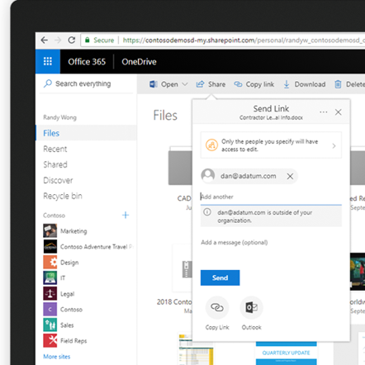 |  | File sharing made easy  OneDrive makes it simple to share files securely with anyone inside or outside of your organization. Apply access controls or additional sharing protections with an expiration date or one-time password as needed.  Learn more »
Hassle-free co-authouring

OneDrive enables real-time co-authoring in familiar desktop apps like Word, Excel and PowerPoint as well as their web and mobile apps. See edits and comments from others as well as be notified of updates and mentions to stay up to date and contribute where needed. You can even track the history of all activity on files, to keep everyone on the same page.

Learn more »
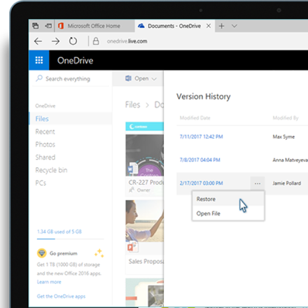 |  | Stay on the same page  When you’re in a pinch, the OneDrive document version history comes in handy. Accidently deleting content doesn’t mean re-work. You can use the version history feature of OneDrive to restore or review older versions of your file.
Tips to share and collborate
- Choose the type of sharing link for your file so you can control if others can edit or not.
- Keep your shared files more secure by requiring a password to access or setting an expiration date
- Securely share with people outside your organization with time-limited single -use verification code.
- Share documents, photos, and videos with others by sending them a link in email, chat message, or text message
- Save time with a single click to attach files to emails in Outlook. You can set access permissions to the file directly in Outlook.
- Copy or move files or folders to locations within OneDrive or your SharePoint document libraries directly from OneDrive.
- Check Version History of the document to refer or review previous versions.
- Use @mentions directly in Word and PowerPoint to notify your co-workers their attention is needed.​
- Work in the same document at the same time in real-time with the latest Office apps or in Office Online.
- Know when your documents are being edited by others with real-time notifications.
Join us on <fill in date> for tips on getting started with OneDrive.
Learn more »
 | Share your questions or feedback. We’re here to help you. <Insert email alias or Yammer group link, or customize this section with more information>
Explore training resources
Find out more about OneDrive »
Explore training resources »
Learn from OneDrive experts »
See scenarios using OneDrive »

