< Insert your company’s logo here. Apply your company’s branding (fonts, colors, illustration or images) to the rest of the document as desired.>
All your files – wherever you are
OneDrive provides a simple, secure, and intelligent way to store, sync, and share files. It’s easy to use and flexible enough so different groups can organize OneDrive to suit their needs.  Learn more » |  |  | 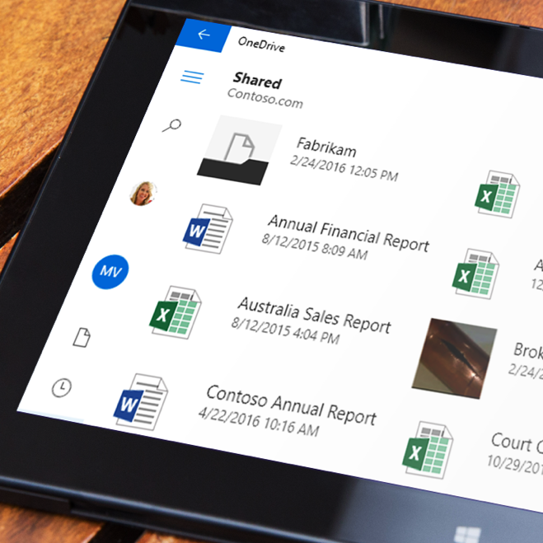
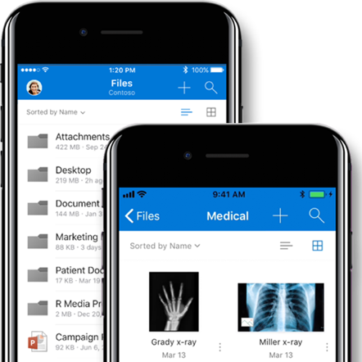 |  | Do more on the go  The OneDrive mobile apps let you work with your files easily when you’re on the go. Access and share your documents, photos, and other files from your favorite Android™, iOS™, or Windows™ mobile devices. View and edit your files using the Office mobile apps to stay productive and co-author documents.  Learn more »  Get the app »
Web access – anytime  The intuitive OneDrive browser experience lets you manage, upload, and share files from anywhere, anytime. Through your favorite browser, you can access all your stored files, SharePoint document libraries, and manage sharing.  Learn more » |  |  |  |  | 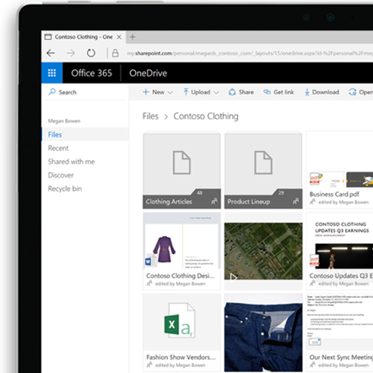
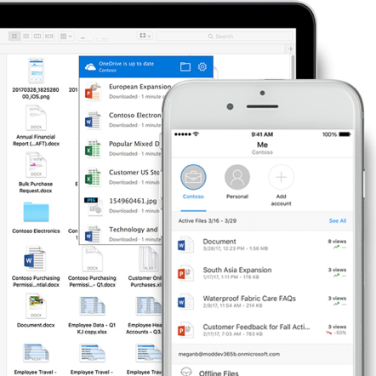 |  | The right file – online or offline  With OneDrive, sync files to your PC or Mac, so you always have the latest version of your files. You can sync OneDrive and SharePoint files or folders, so you can view and edit files anytime, whether you're connected or offline on your Mac or PC.  Sync files and folders »  OneDrive files on Demand »
Quickly find files  Use built-in search and discover tools to find  the most relevant files that matter to you so you can spend more time getting things done rather than recreating work. Quickly get back to your recent or shared files from any device and let others find your work. All your files are private unless shared by you.  Learn more » |  |  |  | 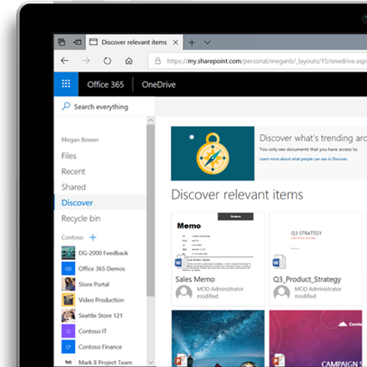
Tips to access and find files
- Access shared files from Microsoft Teams, SharePoint, or Outlook all from OneDrive.​​
- Access and share files from File Explorer in Windows or Finder.​
- You can access OneDrive on your laptop, tablet, and phone to easily view, edit, and share files from anywhere.​
- Select and sync files to your device and check their status in the Activity Center.
- Recent view, Shared by me/ Shared With me view help you to get back to your most accessed files quickly.
- Use “Discover View” to find the most relevant content based on who you work with and what you’re working on. The information in the Discover view is tailored to each user and doesn't change permissions. You will only see what you already have access to.
- Hover your mouse over a file to see file details including access stats (number of views, who viewed and who modified).
- Use your mobile device to scan paper docs into digital docs, including receipts, business cards, and even whiteboard notes.​
- You can search your photos and images by the things in them.​ For example, find a business card by searching for the individual’s name or an unnamed receipt/whiteboard capture by searching the words “receipt”/ “whiteboard”
- “Me tab” in your OneDrive mobile app helps you see the trends and views on your files.​
- ​View more than 320 different file formats right in OneDrive, including Office documents, PDFs, Adobe Photoshop, Adobe Illustrator, DICOM and 3D files.​
- If you suspect your files have been compromised, restore them from any point in time during the last 30 days using File Restore in Settings.
Join us on <fill in date> for tips on getting started with OneDrive.
Learn more »
 | Share your questions or feedback. We’re here to help you. <Insert email alias or Yammer group link, or customize this section with more information>
Explore training resources
Find out more about OneDrive »
Explore training resources »
Learn from OneDrive experts »
See scenarios using OneDrive »

