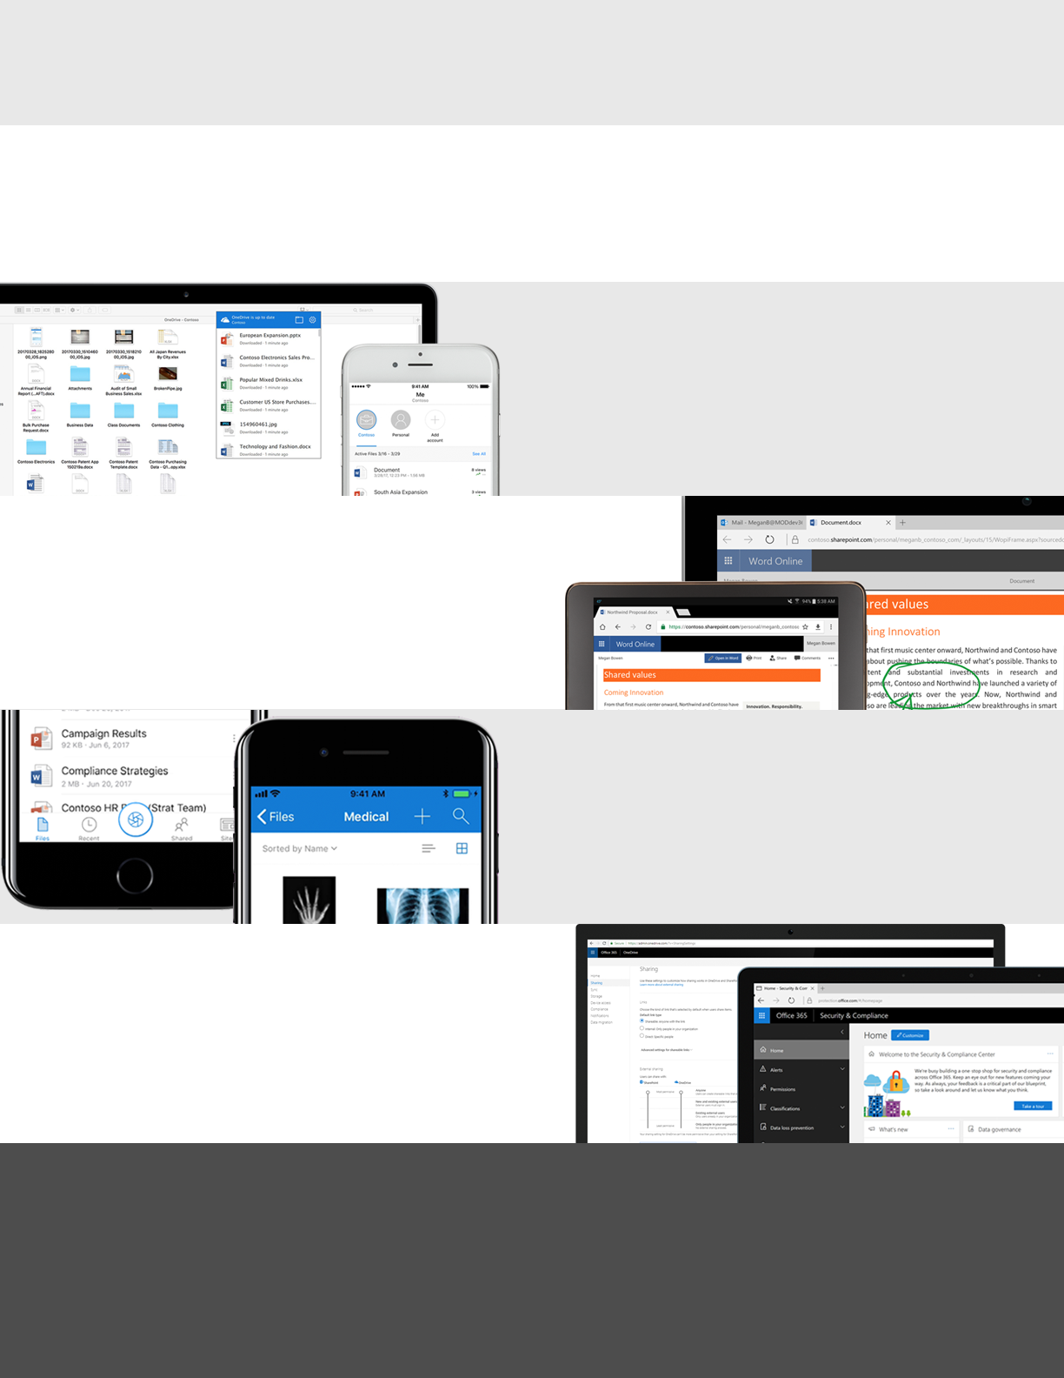­

**Access, share, and collaborate on all your files from anywhere**

<Insert your company’s logo here. Apply your company’s branding (fonts, colors, illustration or images) to the rest of the document as desired.>

Macintosh HD:Users:speaslee:Desktop:concept1.png­­

Seamless collaboration

Controls for security

Don’t worry about losing your files as OneDrive keeps them protected and backed up. Recover your files from malicious attacks and undo accidental deletes for up to 30 days. Administrators can manage security policies, audit sharing activities and usage reports, set device access rules or remotely wipe devices that are lost or stolen—all from the admin center. Microsoft has robust controls and systems built into Office 365 to help keep your information safe.

Stay connected with your files and folders from anywhere with the OneDrive mobile app for Android™, iOS®, and Windows. Access files online or offline and edit and share your files when you’re on the go. Integration with the Office mobile apps allow you to view, edit, and create documents with the familiar Office interface. Capture whiteboards and scan work receipts, business cards and other paper docs into OneDrive.​

Untethered mobility

Easily store and access personal and shared work files in Office 365 from all your devices. Sync local copies of files for offline viewing and editing on your PC or Mac, and save space on your Windows 10 PC by enabling OneDrive Files On-Demand. Quickly find the files that matter to you by searching for files across your organization in Office 365, you can even query content inside photos and images.

Work faster and smarter with anyone inside or outside your organization. Securely share files, applying additional sharing protections with an expiration date or password as needed. You can always see who has viewed, modified, or shared your files.​ OneDrive enables real-time co-authoring in familiar apps like Word, Excel and PowerPoint across web, mobile and desktop. Save time with a single click to attach files to emails in Outlook.

Anywhere access

OneDrive connects you to all your files in Office 365 so you can share and work together from anywhere while protecting your work.

<Add your message here: Lorem ipsum dolor sit amet, consectetur adipiscing elit. Donec mattis enim eu lorem malesuada hendrerit. Suspendisse eget quam et ipsum pretium ultrices. (200 character max).>

For additional guidance, video tutorials and tips, visit Office 365 Training Center

Learn what you can do with OneDrive

!