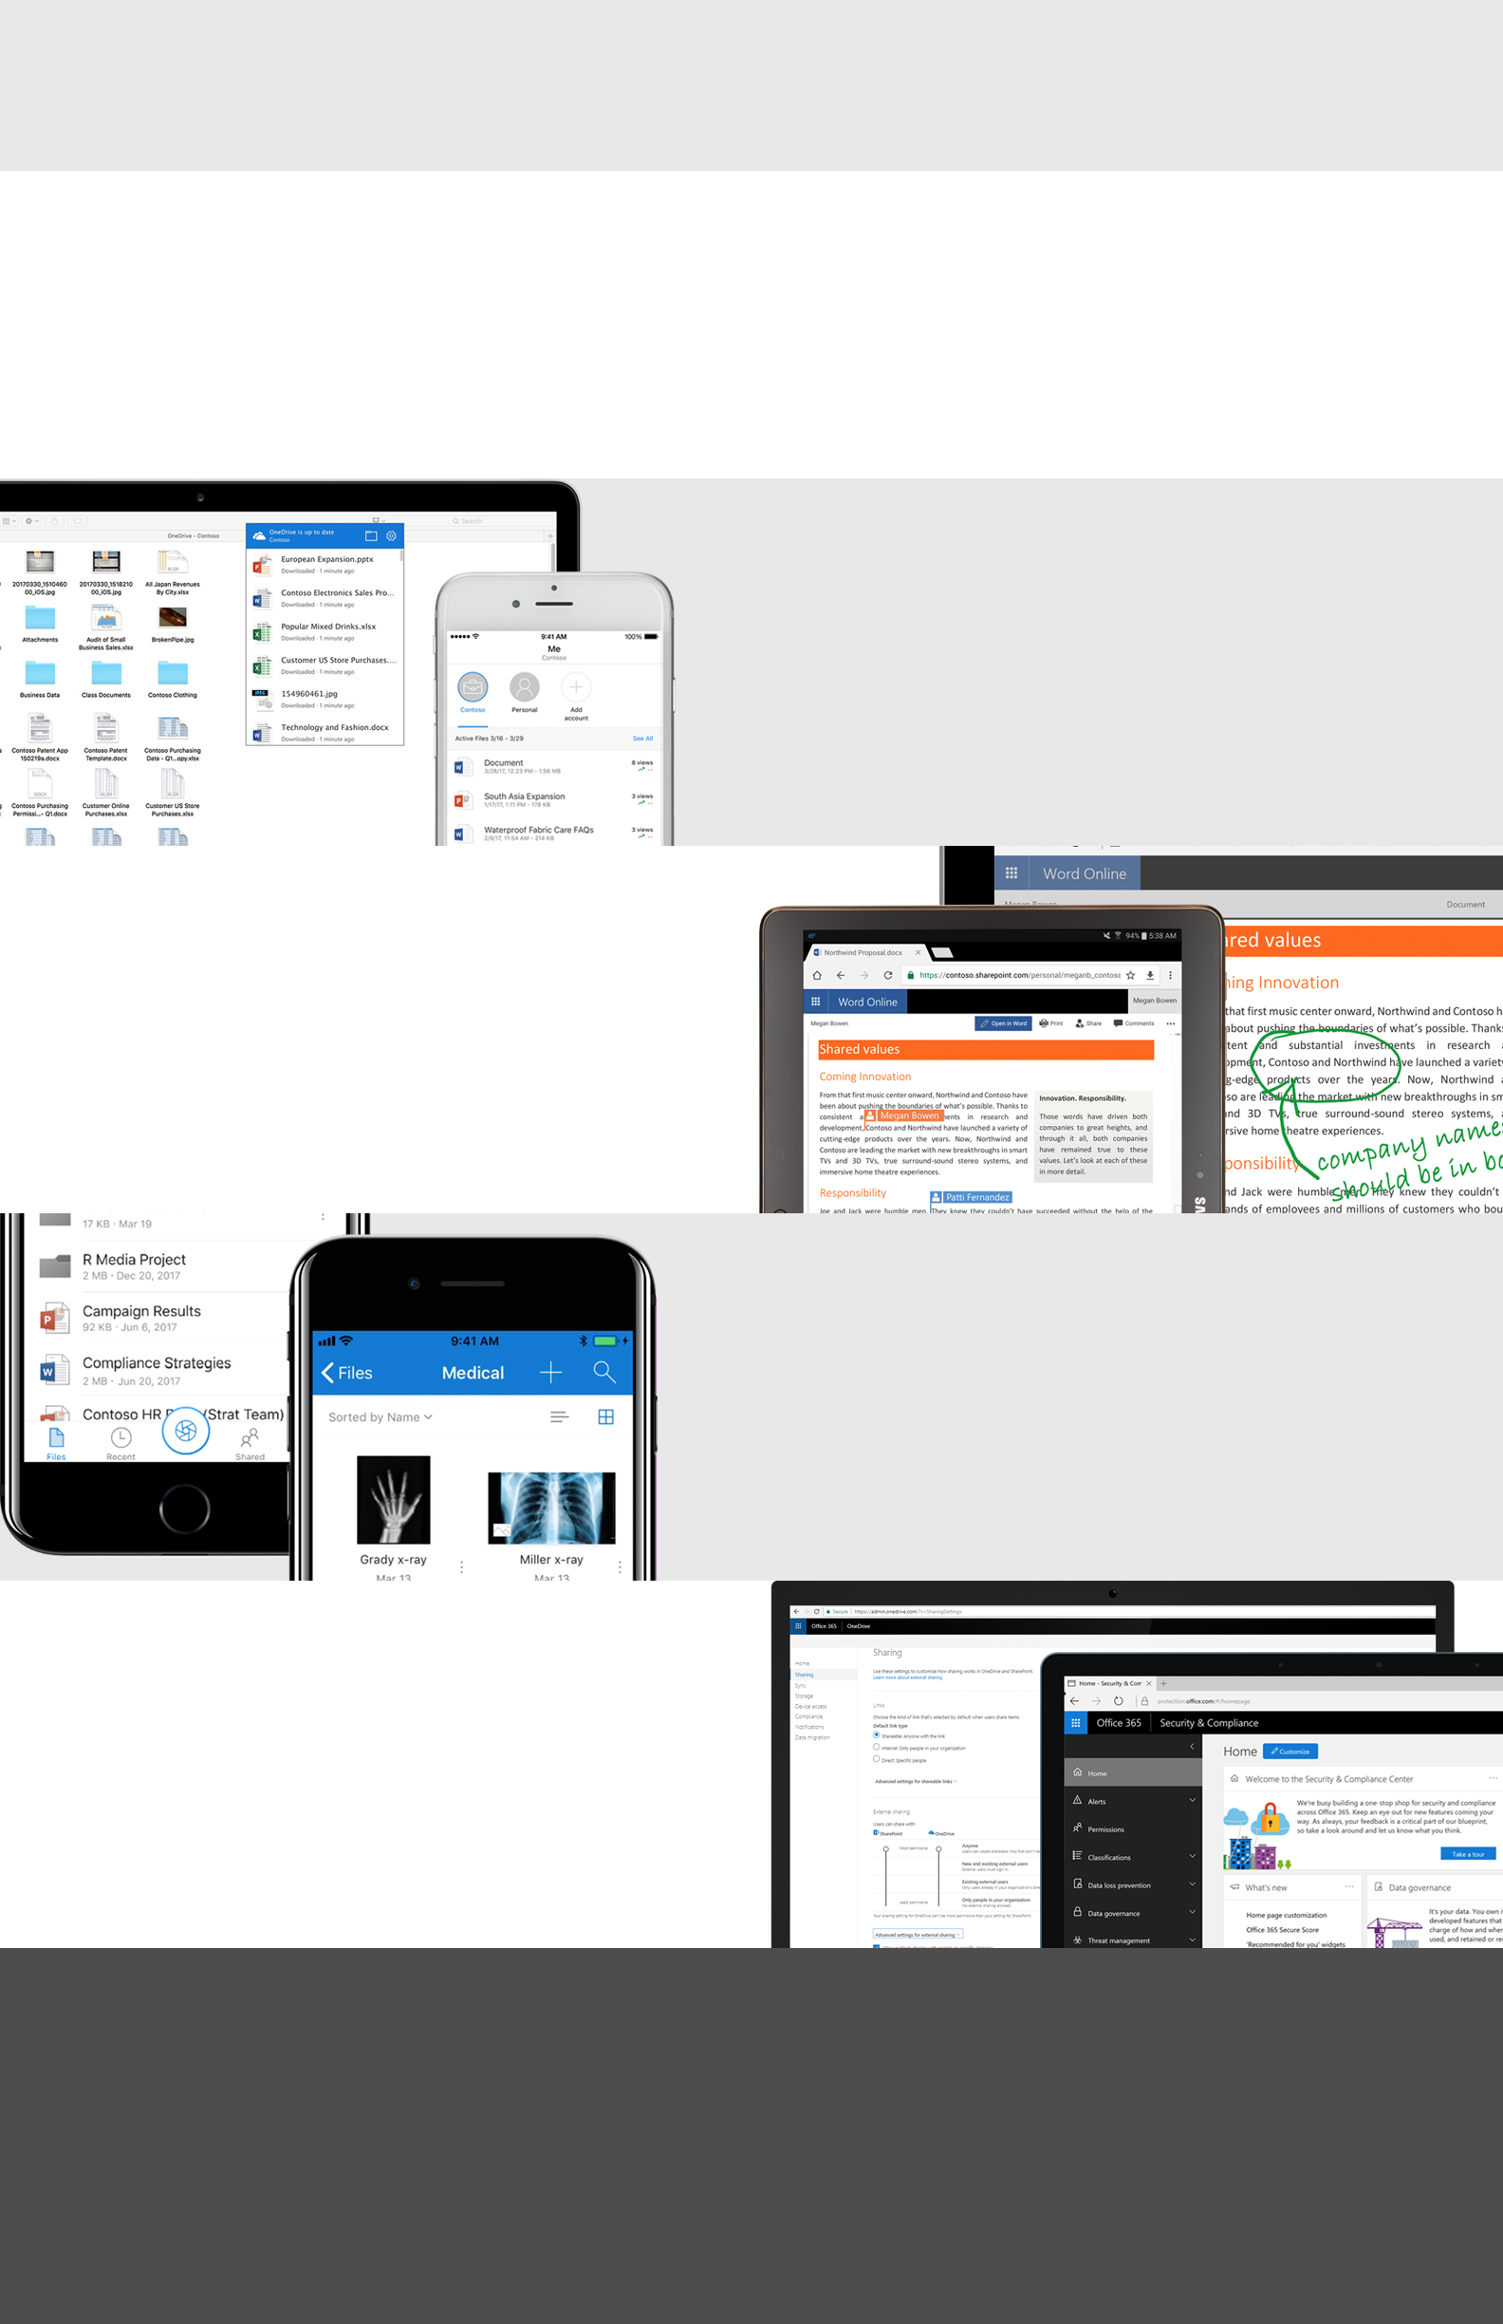Macintosh HD:Users:speaslee:Desktop:concept1.png­

Access, share, and collaborate on all your files from anywhere

OneDrive connects you to all your files in Office 365 so you can share and work together from anywhere while protecting your work.

Anywhere access

Controls for security

Untethered mobility

Seamless collaboration

<Add your message here: Lorem ipsum dolor sit amet, consectetur adipiscing elit. Donec mattis enim eu lorem malesuada hendrerit. Suspendisse eget quam et ipsum pretium ultrices. (200 character max).>

For additional guidance, video tutorials and tips, visit Office 365 Training Center

<Insert your company’s logo here. Apply your company’s branding (fonts, colors, illustration or images) to the rest of the document as desired.>

Learn what you can do with OneDrive