< Insert your company’s logo here. Apply your company’s branding (fonts, colors, illustration or images) to the rest of the document as desired.>
Access, share, and collaborate on all your files from anywhere
On <fill in date> we’re rolling out OneDrive, the smarter storage solution. OneDrive makes it easy to store, share, and collaborate on documents from anywhere. Seamless integration with Office lets you start co-authoring a document on one device and finish co-authoring it on another, and you can select from a variety of tools to annotate, highlight, and comment on it. Access and make changes that sync automatically in the cloud or sync local copies of files for offline viewing and editing on your PC or Mac.
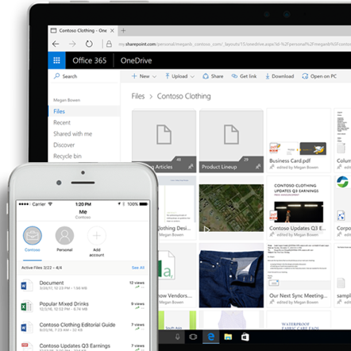 |  | Anywhere access  Easily store and access personal and shared work files in Office 365 from all your devices. Sync local copies of files for offline viewing and editing on your PC or Mac and save space on your Windows 10 PC by enabling OneDrive Files On-Demand. Quickly find the files that matter to you by searching for files across your organization in Office 365, you can even query content inside photos and images.
Seamless collaboration  Work faster and smarter with anyone inside or outside your organization. Securely share files, applying additional sharing protections with an expiration date or password as needed. You can always see who has viewed, modified, or shared your files.​ OneDrive enables real-time co-authoring in familiar apps like Word, Excel and PowerPoint across web, mobile and desktop. Save time with a single click to attach files to emails in Outlook. |  |  |  | 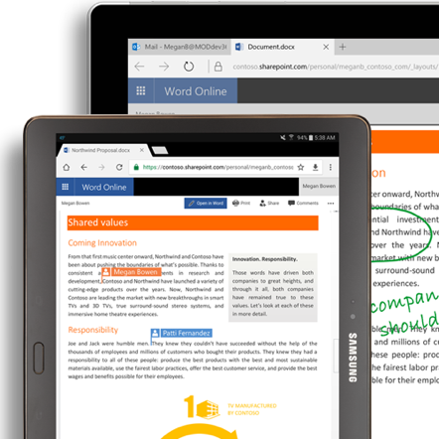
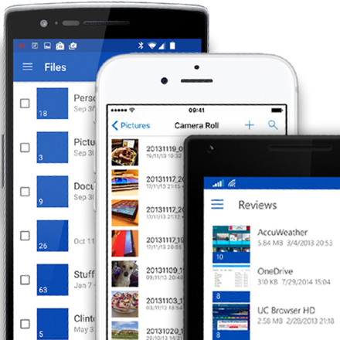 |  | Untethered mobility  Stay connected with your files and folders from anywhere with the OneDrive mobile app for Android™, iOS®, and Windows. Access files online or offline and edit and share your files when you’re on the go. Integration with the Office mobile apps allow you to view, edit, and create documents with the familiar Office interface. Capture whiteboards and scan work receipts, business cards and other paper docs into OneDrive.​
Controls for security  Don’t worry about losing your files as OneDrive keeps them protected and backed up. Recover your files from malicious attacks and undo accidental deletes for up to 30 days. Administrators can manage security policies, audit sharing activities and usage reports, set device access rules or remotely wipe devices that are lost or stolen—all from the admin center. Microsoft has robust controls and systems built into Office 365 to help keep your information safe. |  |  |  | 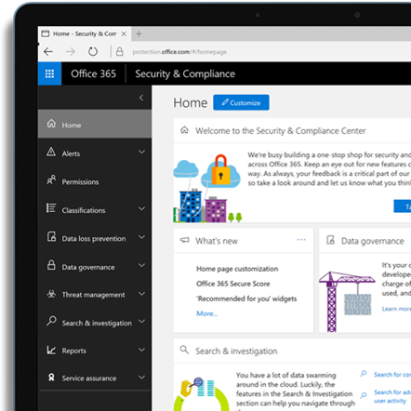
Join us on <fill in date> for tips on getting started with OneDrive.

Learn more »
 | Share your questions or feedback. We’re here to help you. <Insert email alias or Yammer group link, or customize this section with more information>
Explore training resources
Find out more about OneDrive »
Explore training resources »
Learn from OneDrive experts »
See scenarios using OneDrive »

