< Insert your company’s logo here. Apply your company’s branding (fonts, colors, illustration or images) to the rest of the document as desired.>
Announcing OneDrive
OneDrive is here!

Your new tool will make it easy to collaborate, manage, and share your documents from anywhere and any device. Use OneDrive as the primary place for secure file storage, syncing, and sharing. It’s easy to use and flexible enough so different groups can organize OneDrive to suit their needs.

Learn more »
Features focused on the way you work
OneDrive gives you:

- Access to your files at any time, from anywhere, on your favorite devices
- Ability to share internally and externally your organization
- Easy co-authoring without the hassle of versioning
- Seamless integration with your favorite Office apps
- Trusted security features you can rely on
- Quickly find files with intelligent recommendations based on what you are working on and who you are working with.
- A fast, intuitive browser ,mobile , PC and Mac experience

It is the smarter online storage system that makes it simple to create, upload, share and edit files from your desktop, favorite browser, or your mobile devices.
Join the network
Install a sync client on your chosen device.
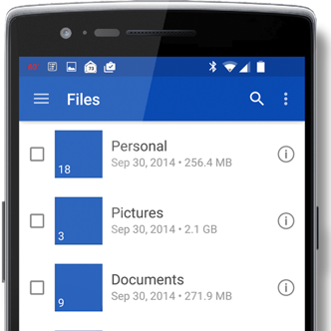 |  | 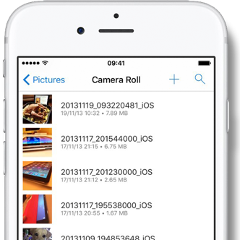 |  | 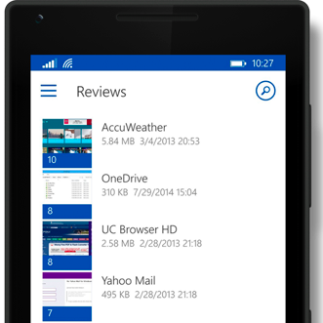
Get the Android™ app |  | Get the iOS™ app |  | Get the Windows™ app
Join us on <fill in date> for tips on getting started with OneDrive.
Learn more »
Share your questions or feedback.
<insert email alias or Yammer group link for company>
Explore training resources
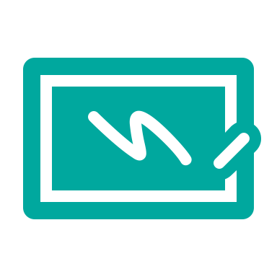 | Find out more about OneDrive »  Explore training resources »  Learn from OneDrive experts »  See scenarios using OneDrive »

