New: Threads in Channels
Table of Contents
Role of channels 1
What are threads in channel? 2
Onboarding guide 2
Create a channel with a threads layout 2
Start a thread 4
Send to thread and channel 5
Follow a thread 6
Follow thread settings 8
Followed threads view 10
Activity feed notifications for threads 11
Catch up on all the threads of one channel 12
Catch up on a particular thread 14
Channel meetings are threads 15
Backwards compatibility 17
Best practices 18
FAQ 20
Q: What are the key things to know about threads in a channel? 20
Q: What’s the best way to catch up on threads? 20
Q: When should I use a threads vs. a post layout channel? 21
Q: How is a channel with a threads layout different from a group chat? 22
Q: What should I do when a decision has been reached in a thread? 22
Q: What should I do if I notice people sending replies outside of the thread? 22
Q: I forked a thread by mistake, what do I do? 23
Q: What can I do to keep my Followed threads view clutter-free? 23
Q: How can I best use Meeting threads? 23
Q: Are bots and apps supported in threads layout channels? 24
Introduction
Organizations are looking to achieve more—and need tools that help them work faster, simpler, and smarter. Guided by customer feedback, Microsoft Teams continues to evolve.
Threads in channels, something many users will be familiar with, are a key part of this evolution. It combines the simplicity of chat-like conversations with the structure, durability, and manageability of channels—helping you stay on top of the information that matters most without getting overwhelmed.

Role of channels
Efficient collaboration moves work forward—and seamless communication is key. Teams need to share knowledge, brainstorm ideas, and resolve challenges quickly.
Channels and chat are both fundamental units of collaboration in Microsoft Teams. Channels are meant for durable collaboration on projects and topics, whereas chats are best for lightweight and transient conversations. Channels have the benefits of centralized ownership, governance, lifecycle, and management capabilities where everything is shared, organized, and easy to find.
Today, chats and channels each support specific collaboration needs. Chats are great for quick, real-time conversations, but can become hard to follow when multiple topics emerge at once. Post layout channels offer structure and clarity, especially for one-to-many communications, but they can feel too formal for fast-paced back-and-forth collaboration.
Threaded channels bring the best of both worlds—fluid, ongoing conversations with clear organization. They allow teams to collaborate dynamically, without losing context or creating fragmented knowledge.
Threads in channels are designed to enhance group collaboration by empowering teams to engage in open, organized conversations that bring together people and, increasingly, AI agents. It combines the simplicity of chat-like conversations with the structure, durability, and manageability of channels—helping you stay on top of the information that matters most without getting overwhelmed
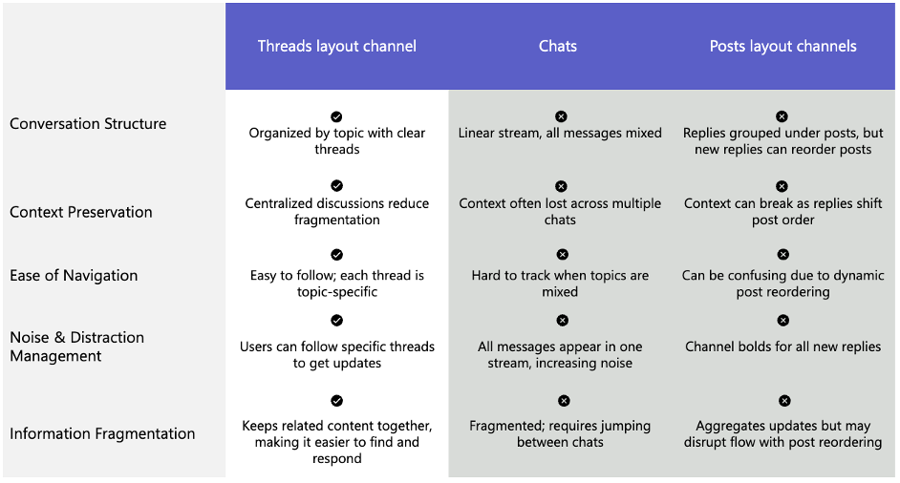

What are threads in channel?
Threads in channels help make collaboration more efficient and focused. With threads, you can reply directly to specific messages with deeper details just a click away. Threads are also linear and do not re-arrange when new replies come in. This preserves context and order, making it easier to stay up to date.
You can follow threads that matter most to you, without getting overwhelmed. When an important update or decision is made, you can send it back to the main conversation to provide visibility for the whole group.

Onboarding guide

Create a channel with a threads layout
To create a new channel with a threads layout, select New items icon> New channel at the top of your chat and channels list. Then, select Threads as the layout.

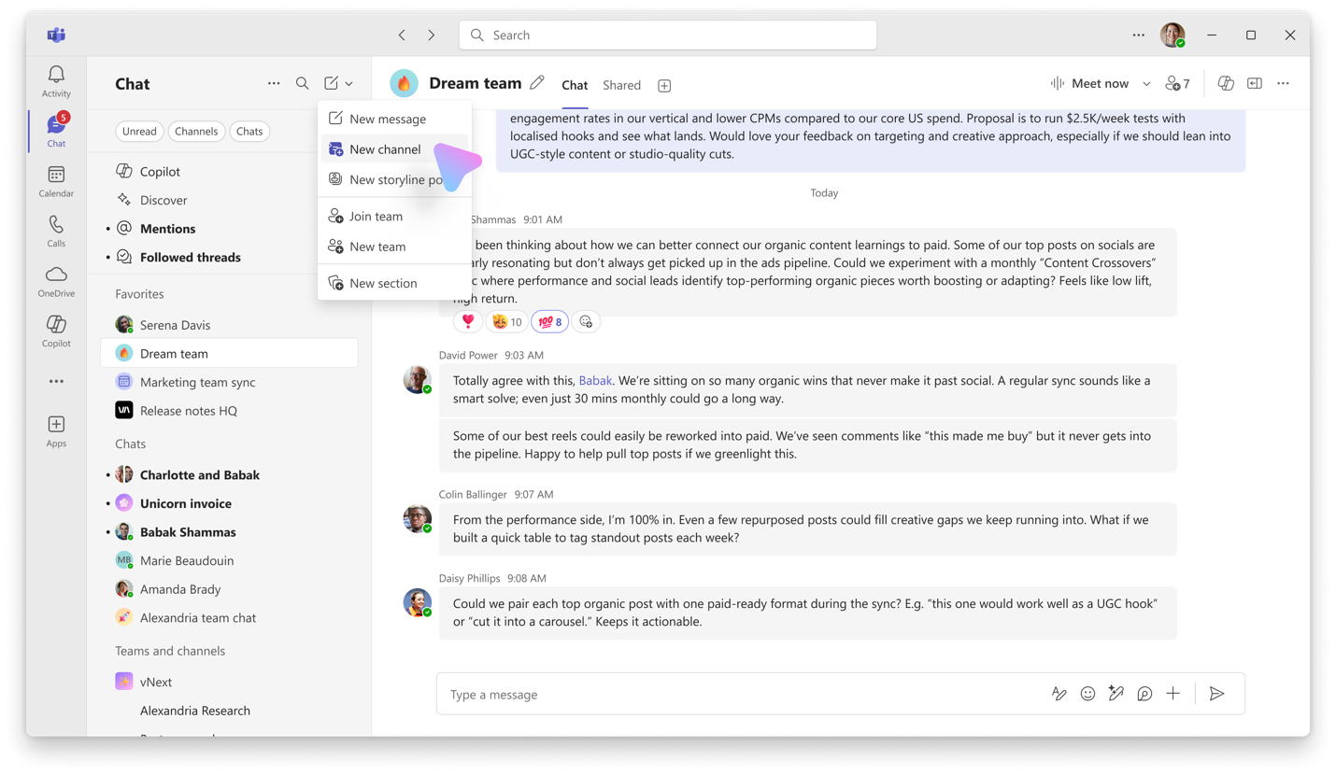
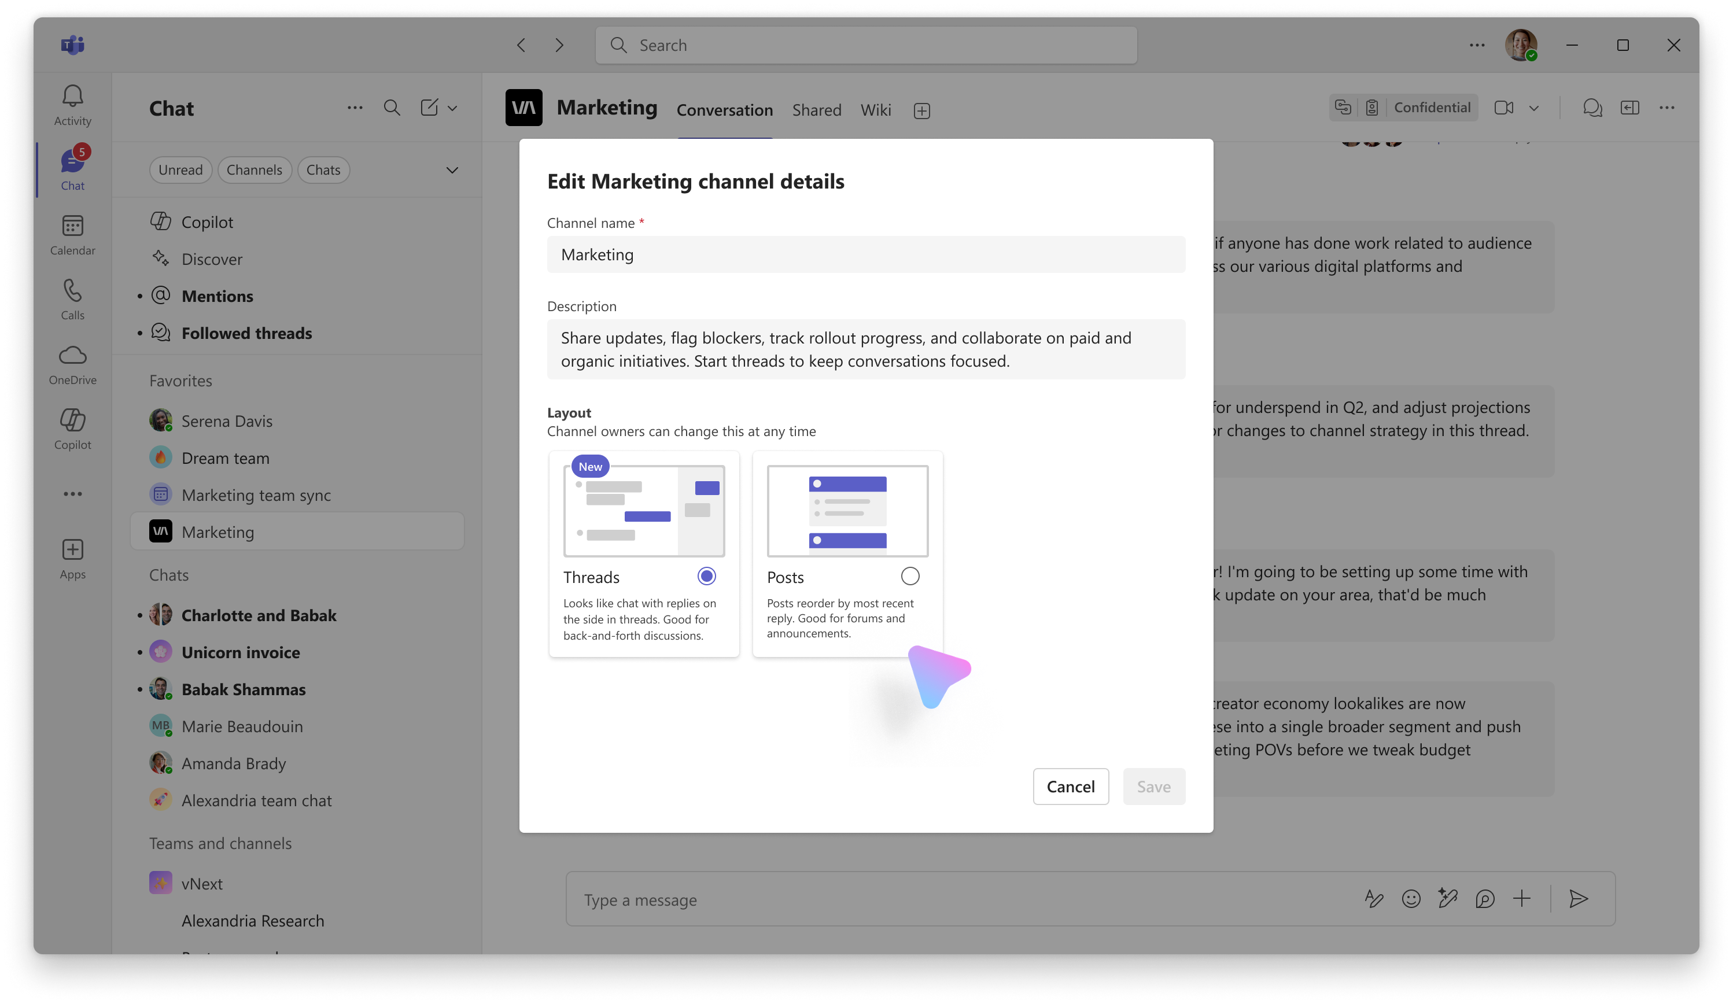

You can convert an existing channel layout from posts to threads. Hover over the channel name in the chat and channel list, select More options > Edit channel. The layout of the channel can be switched back and forth between threads and posts at anytime. Changing the layout changes it for everyone in the channel.

Note: All channels today belong to a team, and permissions for who can create and edit channels are inherited from team permissions. Go to a particular team, then Settings, and you can Allow members to create and update channels. As a team owner, you can always create and edit channels.

Tip: Choose the Shared channel type for more flexibility in channel membership.

Start a thread
Type a message like you normally would in the compose box. In a Threaded channel, a message will send when you type Enter. If you need more time to compose, select the Format option in the compose box – now, Enter will create a new line, and Send button will send your message. If you would like to add an optional title to your message, select the Format option in the compose box.

With threads you can reply directly to specific messages, which starts a thread, keeping related conversations grouped together without disrupting the main conversation. Start a thread by hovering over a message and select Reply in thread icon. Your reply will show up in the side pane, and the count of replies on the original messages will update.
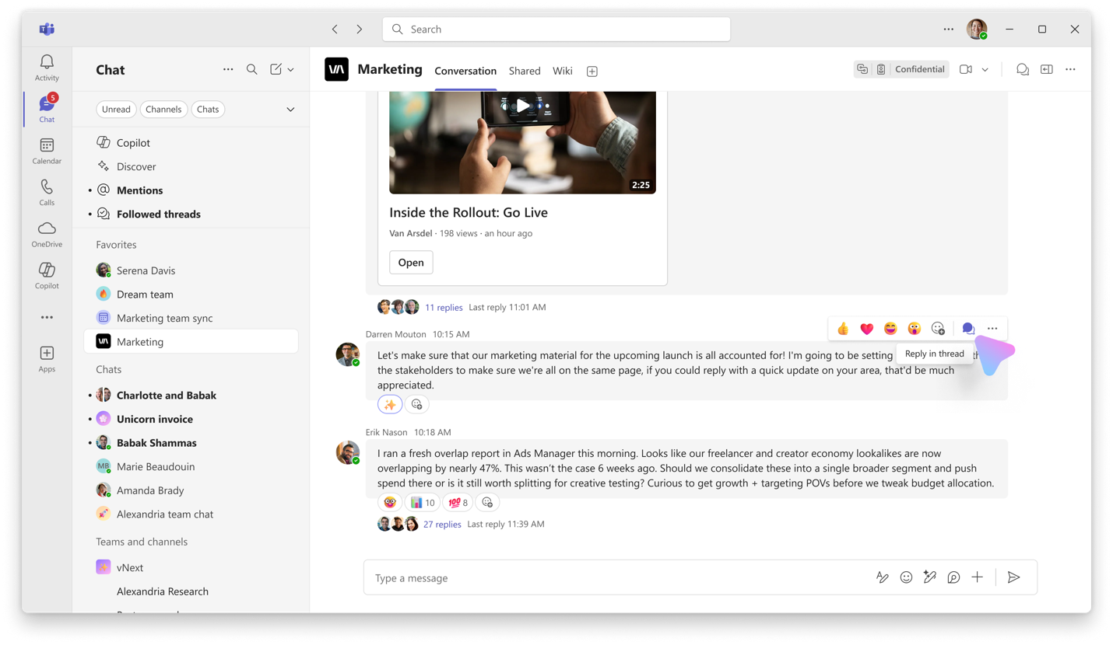
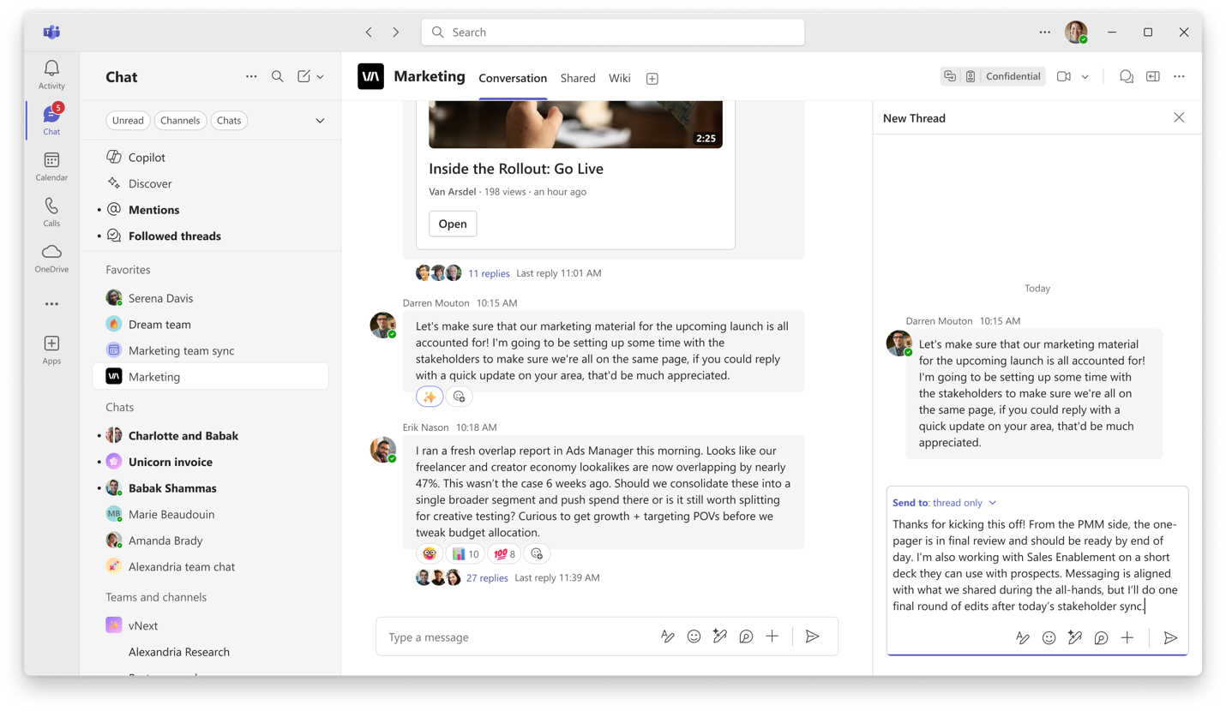
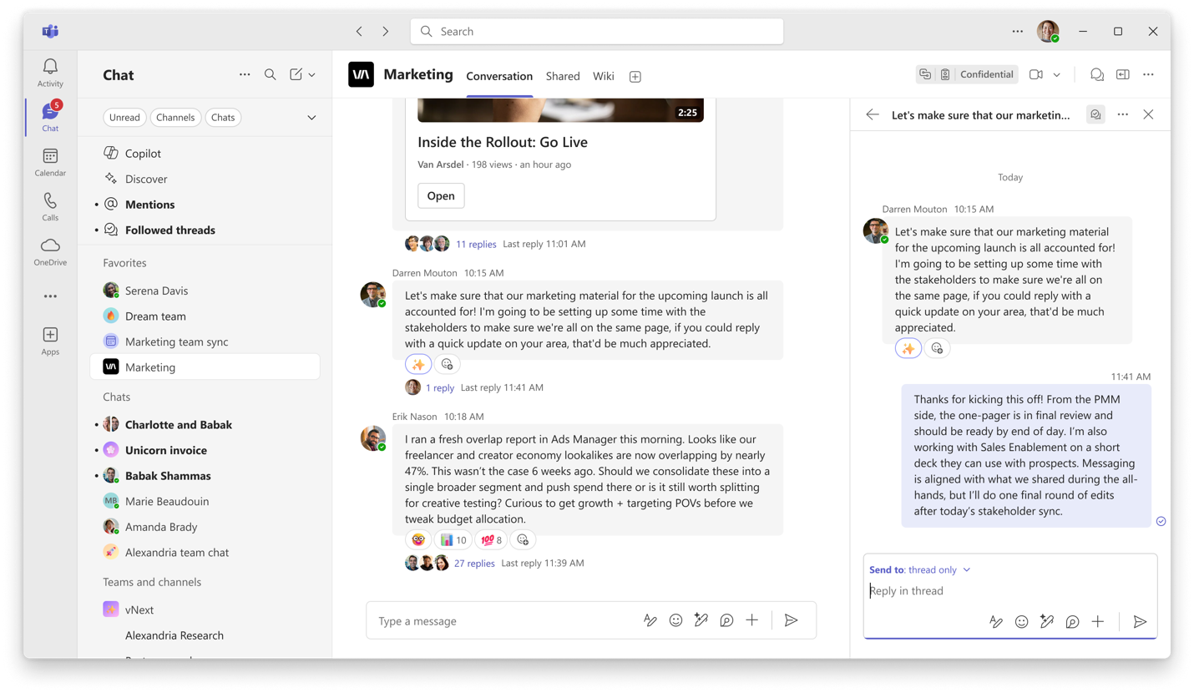

Send to thread and channel
When an important update or decision is made, you can choose to send your message to the thread and the channel. Once sent, the message will appear in both the thread and main channel conversation. Any future replies will stay neatly organized in this same thread, so the conversation doesn’t split into two different parts. This is set per message, and by default, a reply is only sent to the thread.

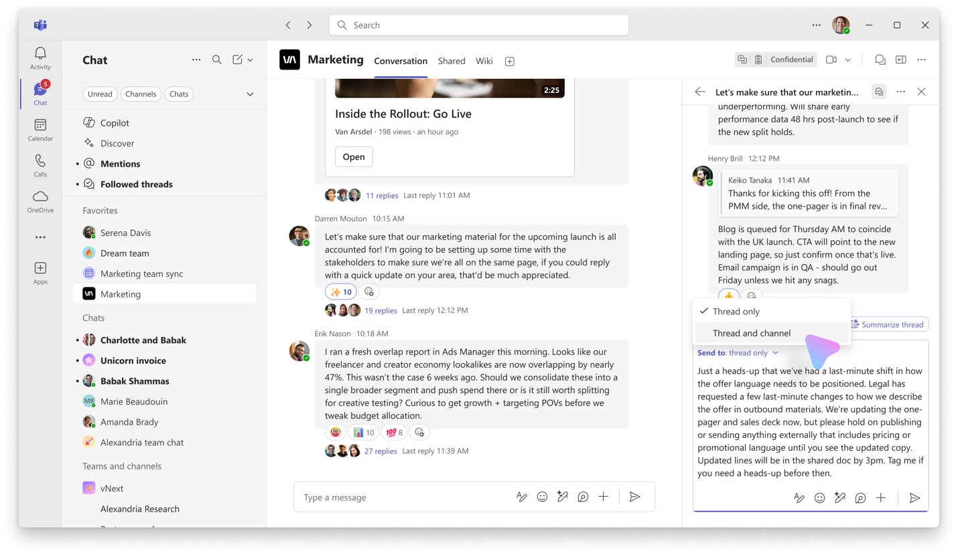
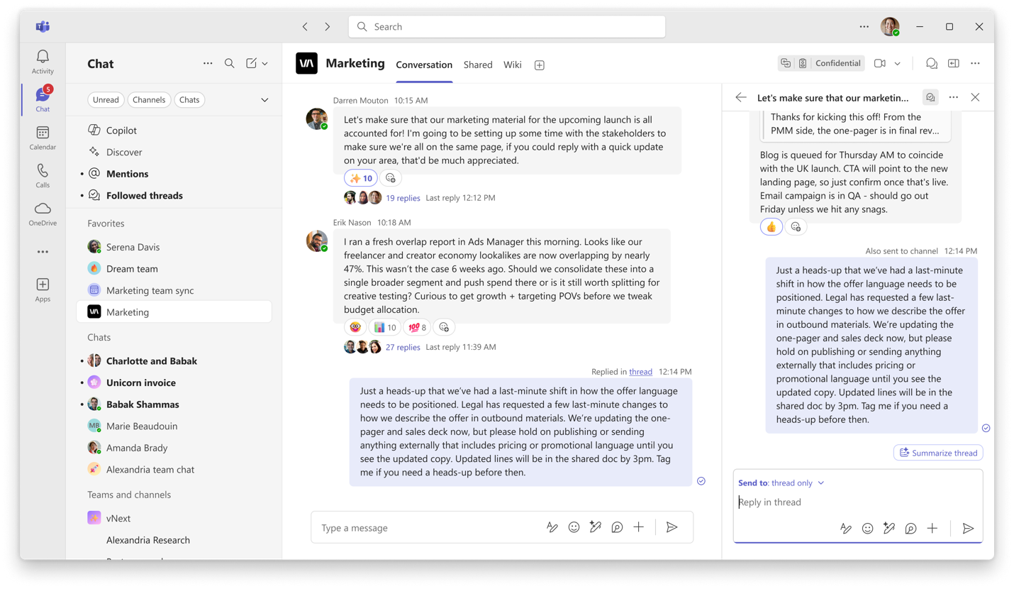

Follow a thread
The new action Follow thread lets you express interest in a thread to receive future updates. This helps you stay on top of the information relevant to you, without getting overwhelmed. A thread can be followed automatically or manually.
- A thread will be automatically followed if...
  - Someone else starts a thread from your original message
  - You replied in the thread
  - You are @mentioned in the thread

- A thread can be manually followed by selecting Follow thread from several locations...
  - From the main channel conversation: Hover over existing replies on a thread and select Follow
  - From the message actions: Hover over a message, select the “...” > select Follow thread
  - From the side pane thread view: select the “...” in the header > select Follow thread

Future updates for followed threads will show up in the Followed threads view.

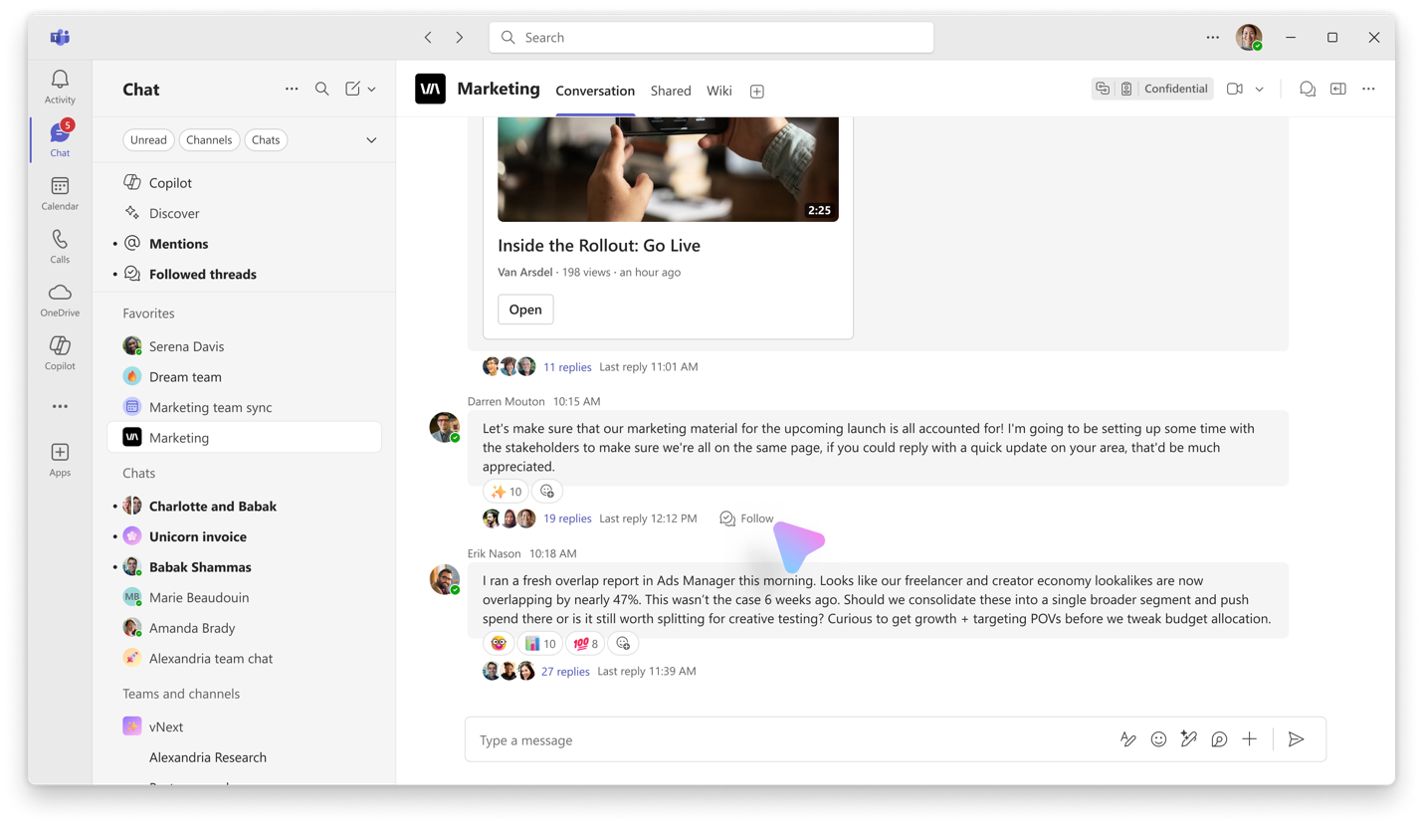

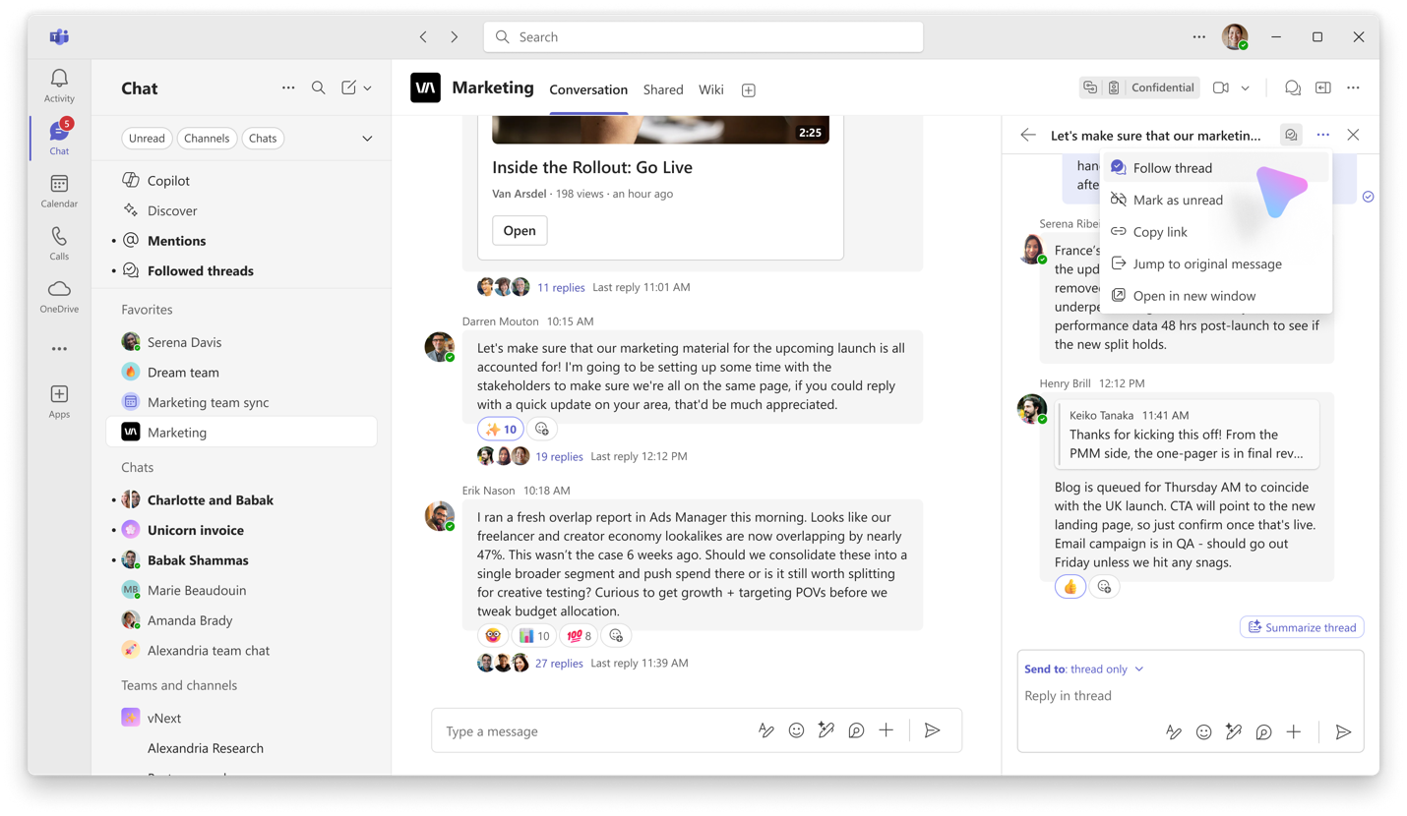
You can also follow a single message that does not yet have any replies if you wish to be notified when future replies come in.
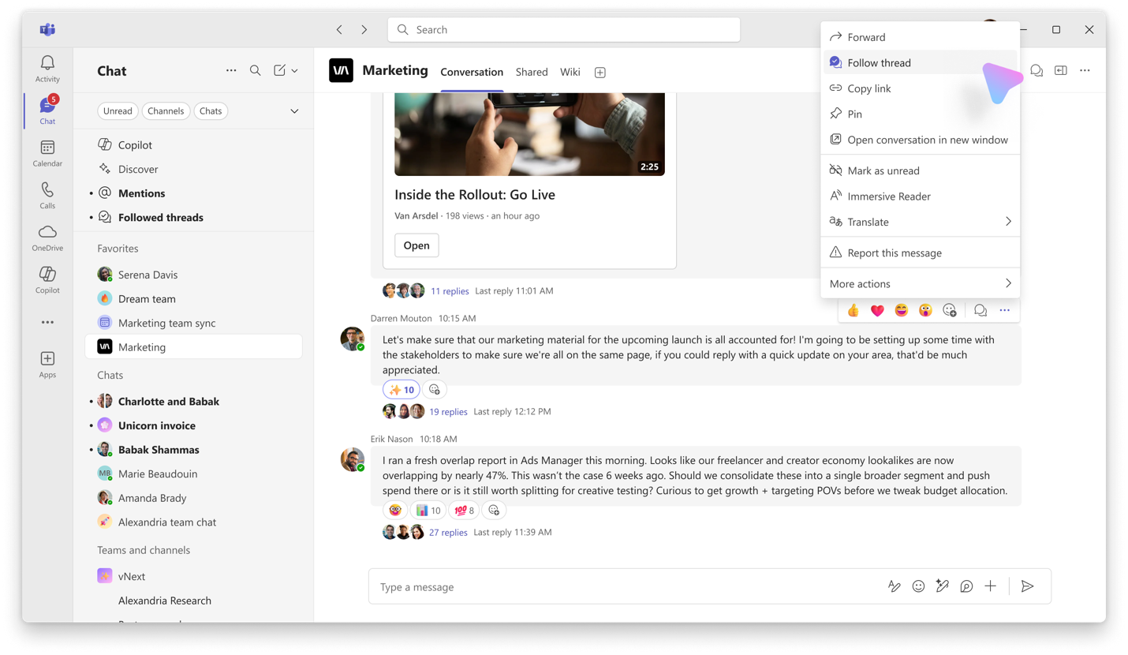

Follow thread settings
You can also configure what threads are automatically followed through Teams settings. This will apply to all your channels, both in threads and posts layouts. Go to Notifications and activity > Chats and channels > Automatically follow threads in channels to fine-tune what you want followed automatically.
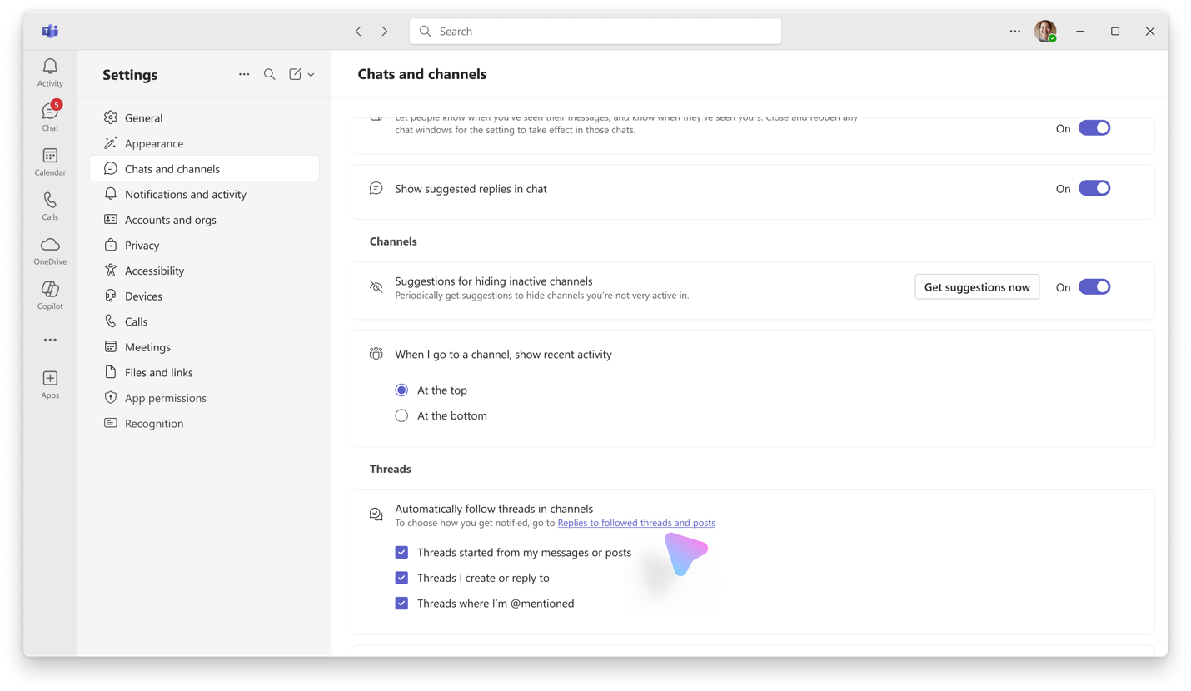

For a particularly important channel, you can configure your settings to automatically Follow all new threads in a channel. Hover over a channel name, select the “...” menu next to the channel name, and select Channel notifications. From there, toggle Follow all new threads to On.

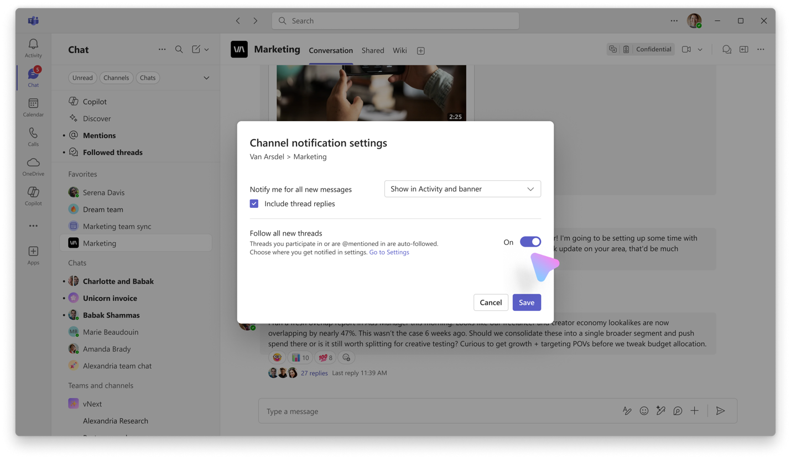

Followed threads view
The Followed Threads view brings all your followed conversations into one interactive list. This view resembles an inbox, you can quickly access all your threads, triage and respond—without jumping between channels.
Navigate to the Followed threads section. If you are in the combined chat and channel mode, you can find the Followed threads section at the top of the chat and channel list. If you are viewing chat and channels separately, you can find this at the top of the teams list.
An unread filter helps you scan what’s new and prioritize at a glance.
Once a thread is no longer relevant, you can also unfollow directly from this view, it will be removed from your list and you will no longer receive future updates on that thread.

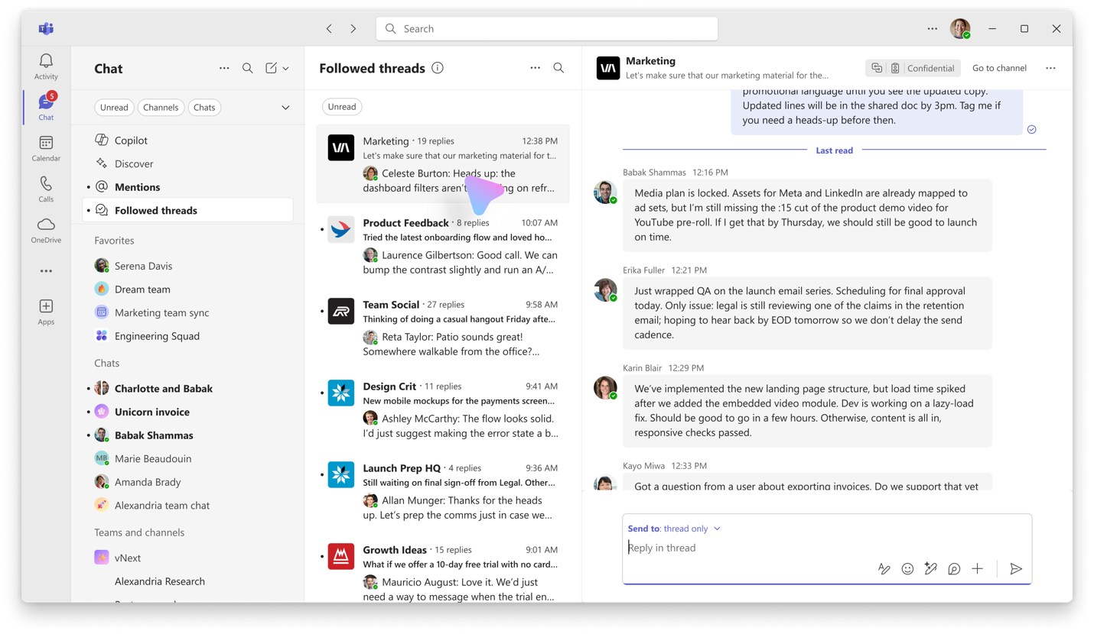

Activity feed notifications for threads
If you prefer to stay up to date through Activity feed notifications, you can go to Notifications and activity > Replies to followed threads and posts and set them to Show in Activity. This will only notify you for threads you have followed automatically or manually.
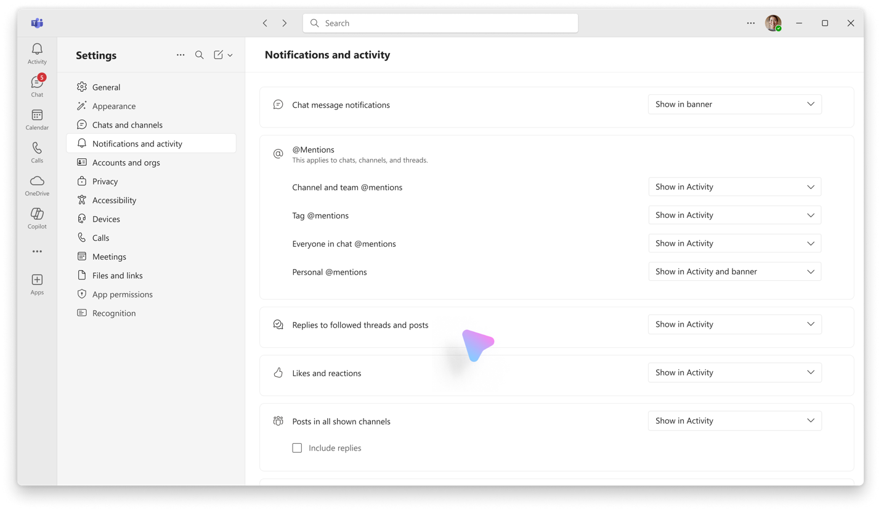
You can also get activity feed notifications for new content in a particular threads channel. Hover over the channel name, select the “...” menu, and select Channel notifications. Here, you can select Notify me for all new messages, which will notify you for any new message in the main channel conversation. If you want to be notified for replies as well, select the Include thread replies check box below.

Catch up on all the threads of one channel
You can find all threads in a channel via the Open threads entry point, located in the upper corner across from the channel title. Threads bold to display unread activity, and re-order based on recency of replies to help you catch up on most recent content.

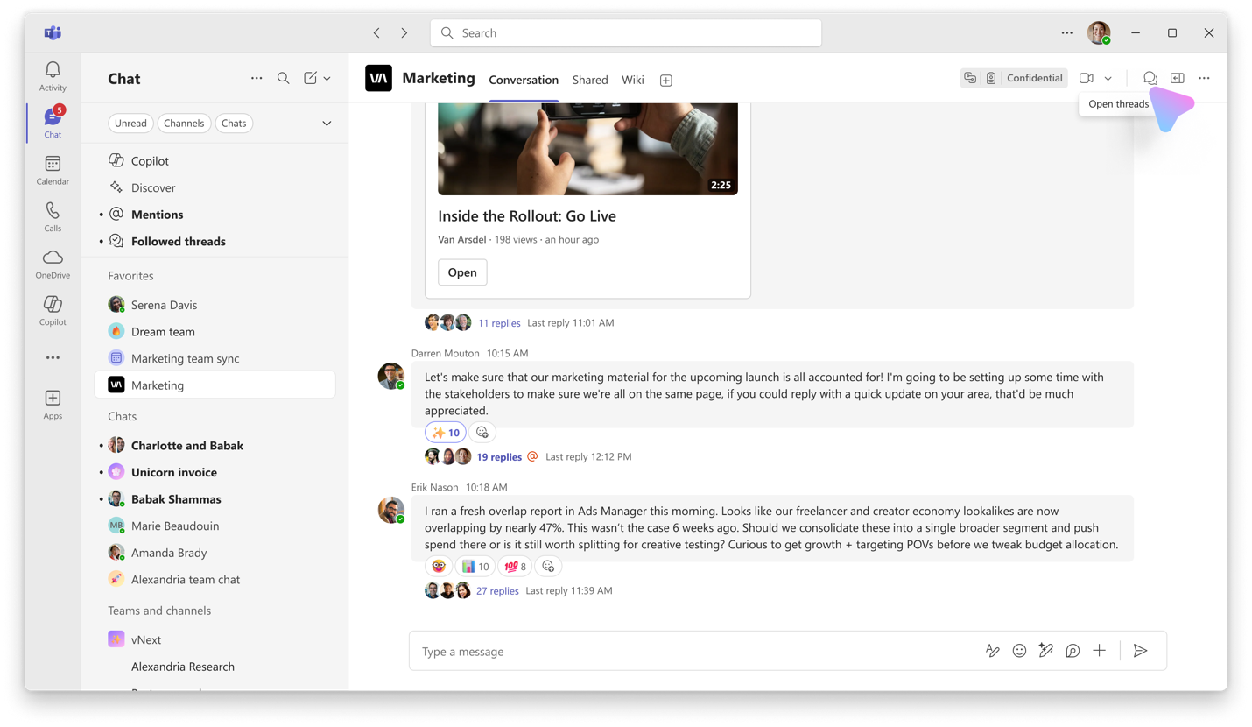
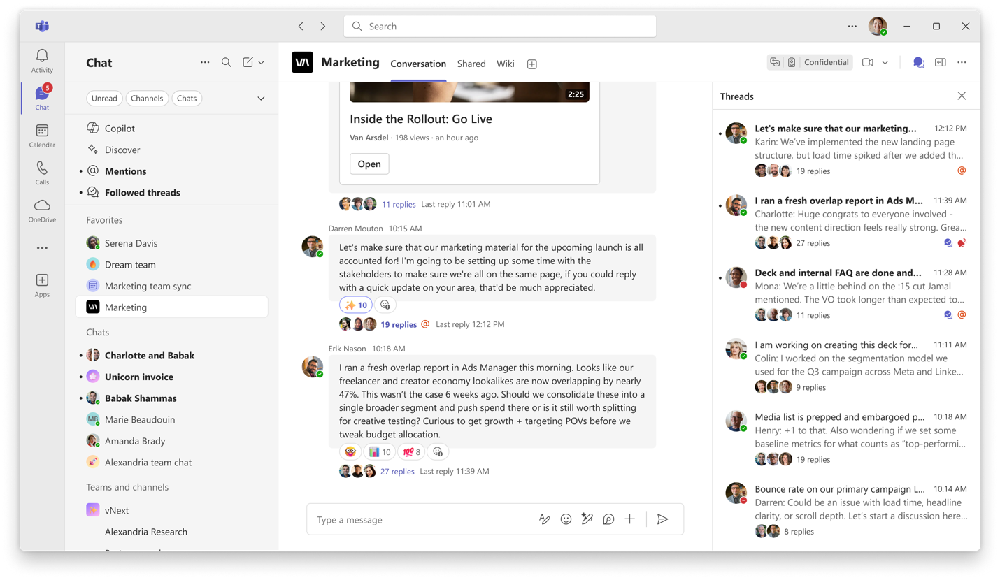

Catch up on a particular thread
With a Copilot license, you can also get an AI-generated summary of a particular thread. From the main conversation view, hover over a thread, select “...” menu for more options, and select Summarize thread. The thread view will open in the side pane and that’s where the summary will show up for only you.

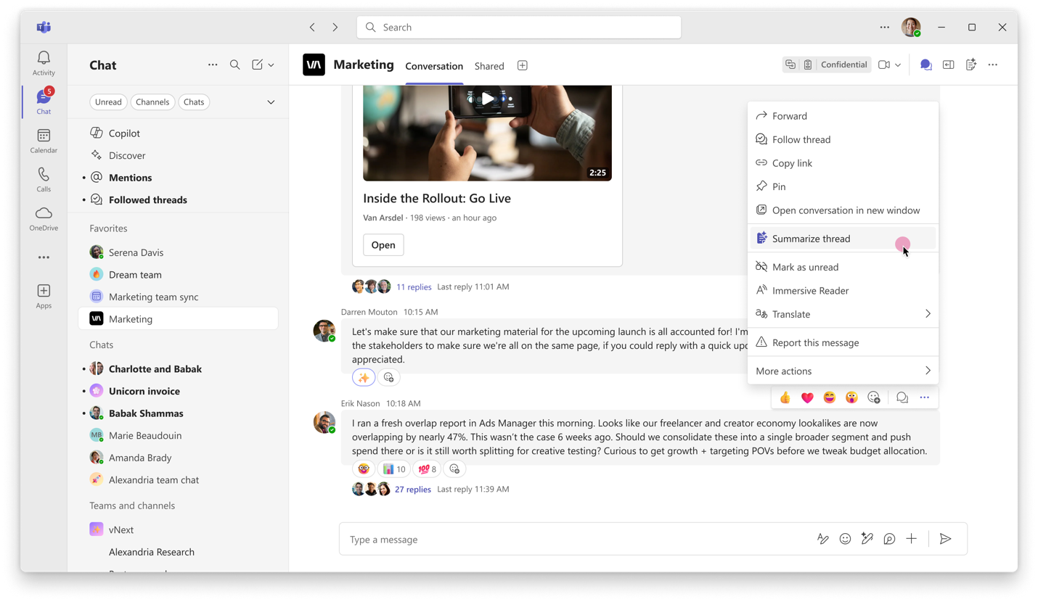

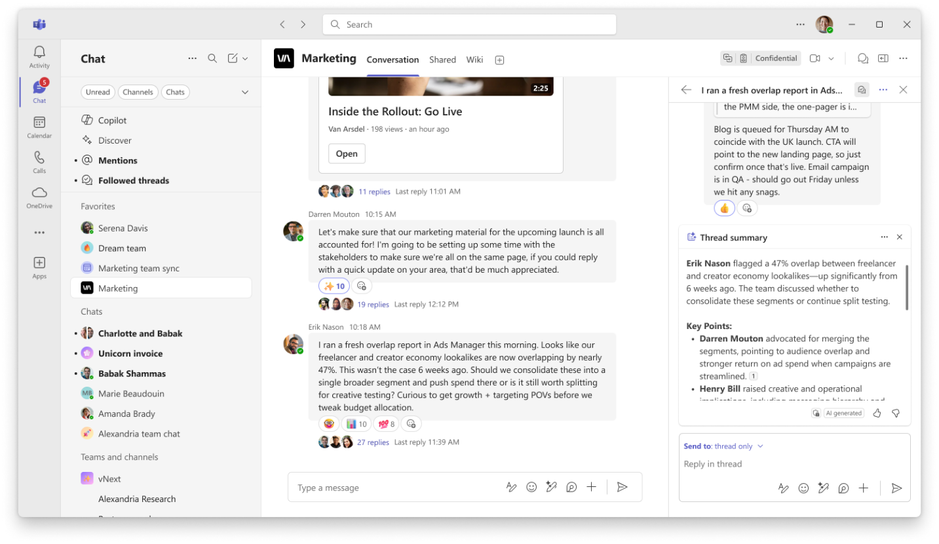

Channel meetings are threads
You can Schedule meeting in a channel to keep all meeting conversations centrally organized in one place. A meeting in a channel will have its own thread, and the thread will be anchored to the meeting object.
To have the meeting show up on relevant people’s Outlook calendars, make sure to add required attendees during meeting creation. If you notice a meeting in the channel that you’d like to have on your calendar, select the “...” menu on the meeting object, and select Add to calendar in the top left corner of the meeting details page.
You can also start a Meet Now for an impromptu meeting. Select the Meet Now button and anyone else can drop in. This does not call anyone in. The conversation in that Meet Now chat will also be a separate thread in the channel for easy organization.
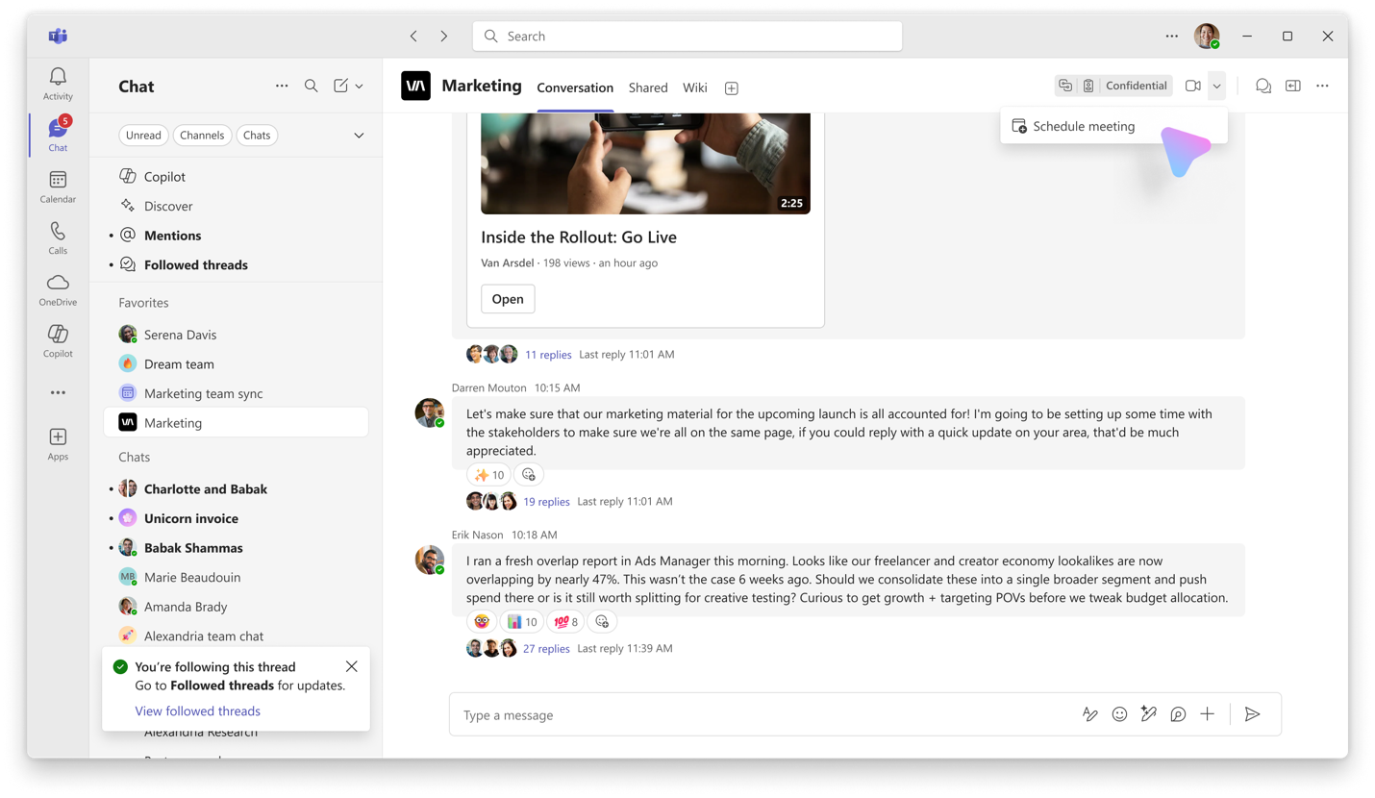
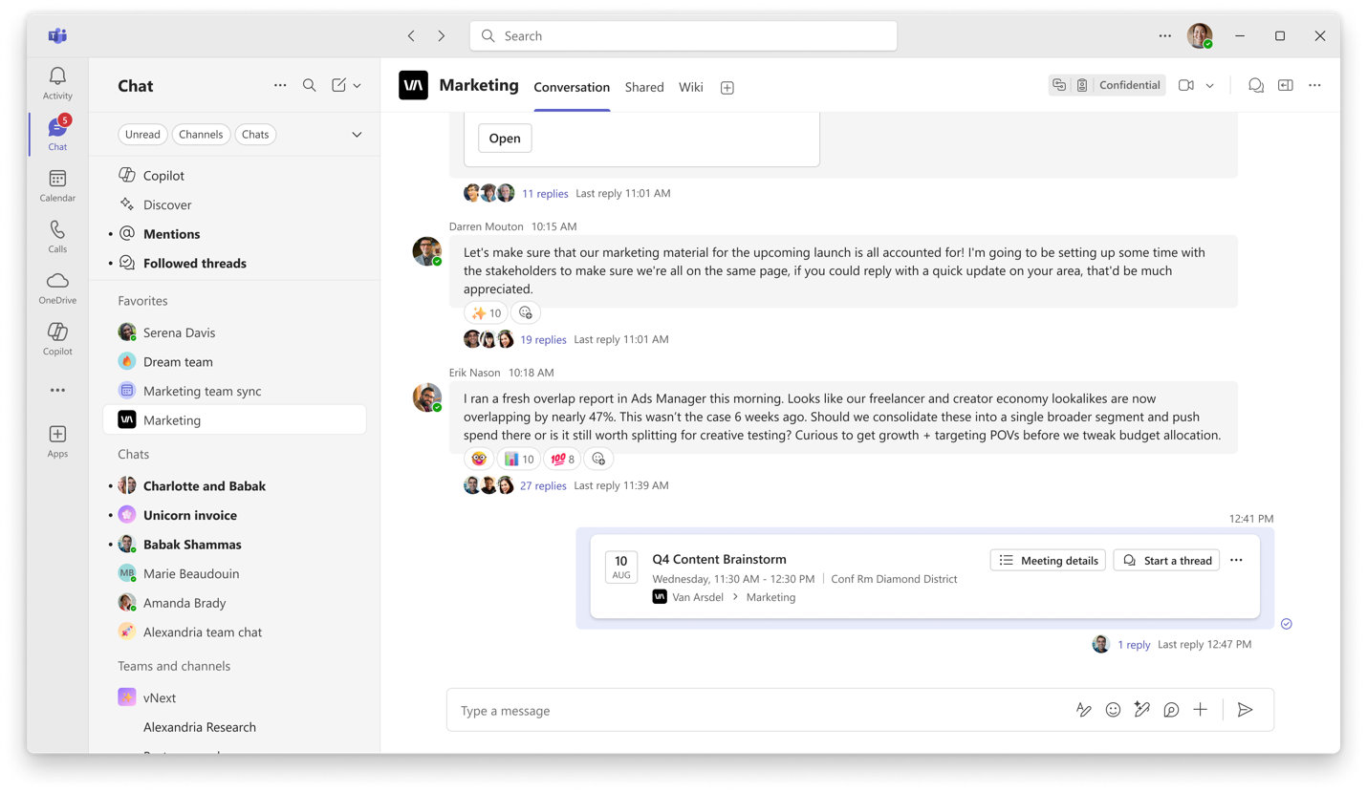

Backwards compatibility
If you do not yet have threads layout available, you will see a threads layout channel in a view that resembles posts channels. A banner will appear at the top letting you know that others are seeing this channel in a different view.
This may cause some messages/posts to render out of order due to new replies reordering posts, may cause some issues with bolding of the channel name due to posts channels bolding for every message and threads channels only bolding for new main channel conversation messages, and may cause some issues with notifications.
If someone doesn’t have threads layout available, we recommend changing the channel to a post layout using ‘Edit channel’ so that everyone has the same view.

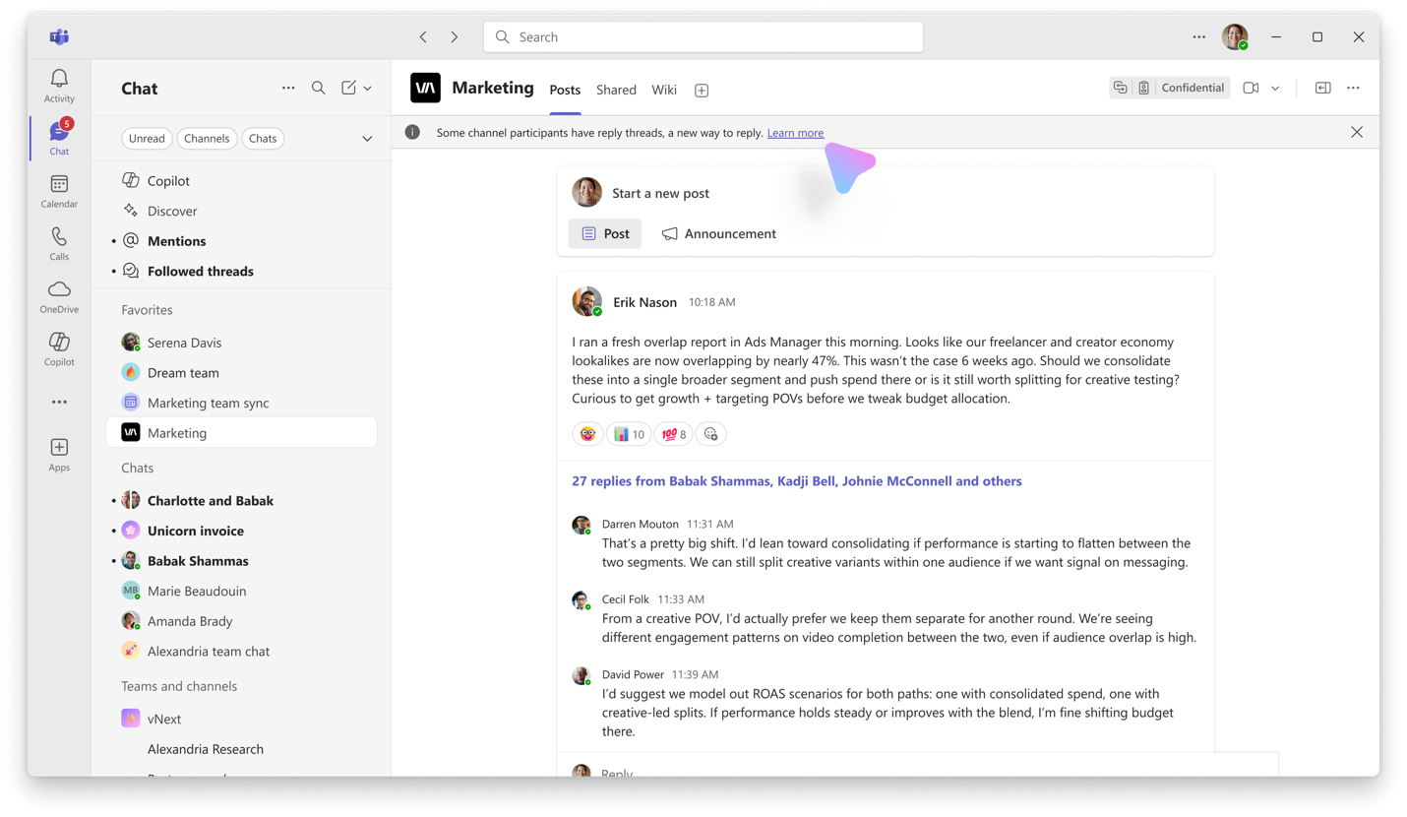

Best practices
Threads keep conversations organized, scannable, and easy to catch up on. Instead of cluttering the main view with replies, threads group related messages together and help people find what they need faster. Think of each thread as its own mini group chat, but out in the open where everyone has shared context.
The best way to use threading is by having short one-liners with details in the replies.
- Main channel = headlines. Start new topics here. Each message should kick off a new conversation.
- Details in the replies. Keep all follow-ups and conversation as replies in the thread to maintain context and prevent the channel from getting messy.
- Emojis on the headline message to indicate acknowledgement, action, or follow ups.
Tips:
- Write short, clear messages in the main channel to start a conversation.
- You can also use titles – select the format option to add a title.
- Use the thread replies for detailed responses, decisions, and back-and-forth.
- Use emojis to react to the headline message to indicate acknowledgement or sentiment.
- Once you reached a decision or outcome, use send to thread and channel to share back to the channel for visibility. If any future replies come in, they’ll still be organized under the main thread.
- Use Compact Mode view to keep the conversation scannable and organized as well. This is just how you view your own content, it will not affect others’ views. Go to Settings > Chats and channels > Message density.

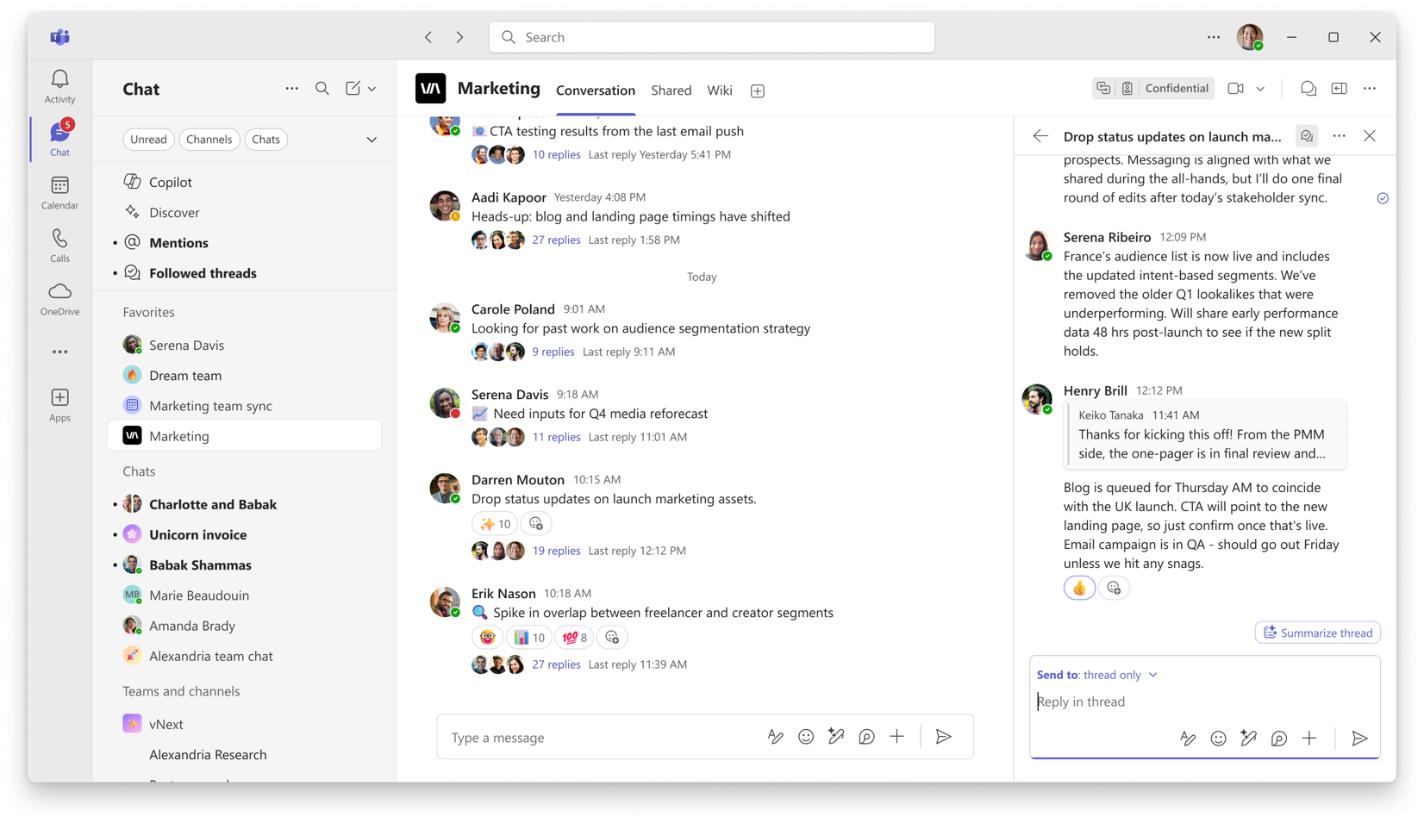
Figure 1: You can use the main message as the topic that the thread will be about, and reply with more details to start a thread. This way, the main channel view stays clear and scannable at a glance.
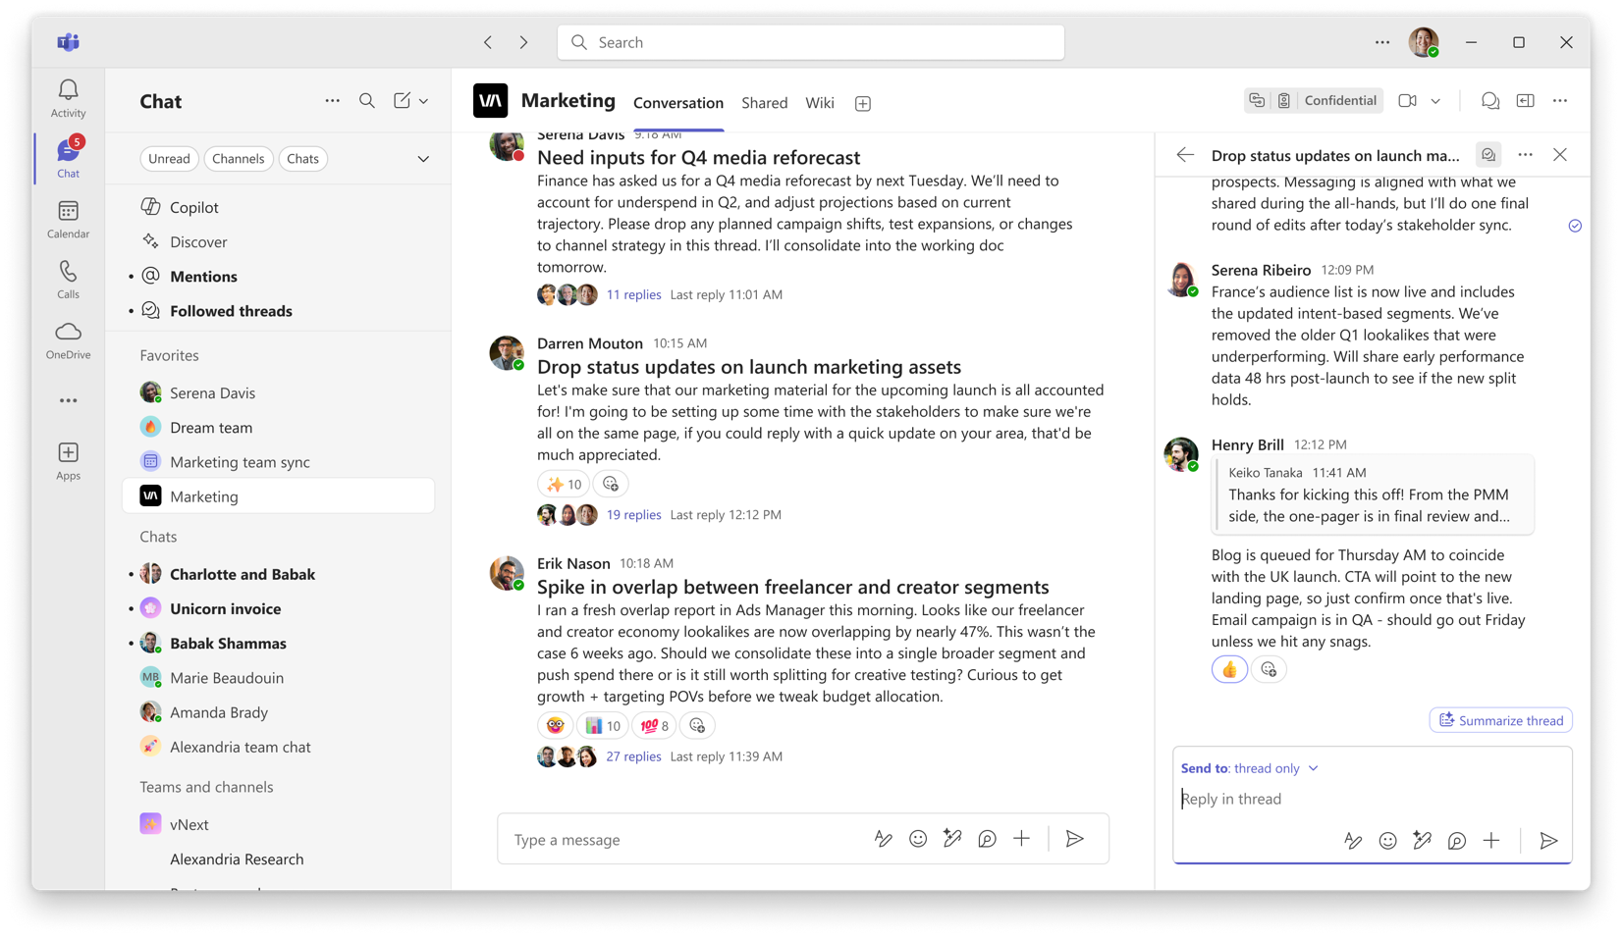
Figure 2: You could also title your message (select Format in compose box) and include the details as part of the message body. This allows you to catch up on content without having to click into the thread unless you need the details.

FAQ

Q: What are the key things to know about threads in a channel?
- Reply in a thread to keep the main conversation organized
- Send to thread and channel to share decisions and outcomes from the thread back to the main conversation for visibility without forking the thread into two parts
- Follow a thread you’re interested in to get future updates from the conversation
- Check the Followed threads view to stay up to date with threads from all channels

Q: What’s the best way to catch up on threads?
You can follow a thread and easily return to it later using the Followed threads view.
You can also customize your Activity feed notifications to alert you to new thread activity. Depending on how you prefer to stay updated in Teams, you can use either or both of these options.
You can move a channel to a section that is pinned near the top and always in your view. In a Threads layout channel, new messages (but not new replies) will bold the channel in the chat and channel list. Note: this is different from a Posts layout channel, where new posts and new replies bold the channel in the chat and channel list.
Finally, you can Follow all threads through channel notification settings for channels of particular interest.

Q: When should I use a threads vs. a post layout channel?
Threads channels are a good choice when...
- You want free-flowing conversation with less formality and rigidity, but still possessing the durability of channels
- You need to have a chronological conversation where ideas build on each other and there's a sequential flow to a conversation
- You want less clutter in the main conversation, since replies are rolled up and not visible in the main view
- You want to minimize noise, and only be notified about particular sub-conversations (threads) rather than everything in a channel
- Example: Collaboration group with a lot of back-and-forth discussion, for example, a team working on a project, incident support, planning an event
Post reply channels work well when...
- You want more structure and rigor for announcements or message boards
- You want to be caught up on details in the replies on every conversation, since conversations are re-ordered based on recency of replies
- Examples: Announcement channel with lengthy posts and one-to-many communication, for example, a channel for a whole company or an organization
Ultimately, it's up to you! Try both (you can switch the channel at any time without losing fidelity) and see what works best for your team.

Q: How is a channel with a threads layout different from a group chat?
Channels with a threads layout come with extra benefits like
- All members of the project are part of the discussion in a channel, with one centralized place to talk about various topics that come up and an easy way to search through previous decisions and outcomes all in one place. This reduces meeting chat sprawl, keep conversations centralized, and simplifies onboarding for someone new to the team with only one place to reference.
- Channels have a SharePoint site for shared content, allowing for a centralized and durable storage space for assets related to a project. If anyone leaves the project or organization, the content will stay available for everyone, ensuring continuity and longevity.
- Chanels benefit from additional governance policies for an organization, allowing better manageability by admins and more robust moderation and permissions tools.
- Channels have flexible notification settings, where everyone in a channel can choose how much or how little they want to be notified allowing everyone to stay informed only on the things most directly relevant to them and reduce noise from other conversations.
We recommend using threaded channels for your long-running project group chats!

Q: What should I do when a decision has been reached in a thread?
Use the Send to thread and channel option to publish the outcome to the main channel view for visibility; this ensures that everyone sees the decision without need to dig through the thread. Any future replies will still be grouped under the same thread.

Q: What should I do if I notice people sending replies outside of the thread?
Gently remind others on your team to respond as a reply in a thread rather than in the main conversation to keep the conversation nicely organized.
Sometimes, a subtle reminder can be reacting with a “thread” emoji on a dangling reply, to remind someone to delete a message and repost it to the thread as a reply.

Q: I forked a thread by mistake, what do I do?
If you meant to reply to a thread but accidentally sent a message to the main channel instead, then it’s best to copy over your content to a reply in the thread, and delete the message from the main conversation to prevent forking.

Q: What can I do to keep my Followed threads view clutter-free?
To keep your Followed Threads view clutter-free, you can adjust your notification settings and unfollow threads.
You can go to the “i” icon near the Followed threads header to take you to Settings where you can adjust what gets automatically followed from that point onward.
You can also unfollow a specific thread once you feel like it is no longer relevant. Select the “...” menu on a given thread within the Followed threads view, and select Unfollow.

Q: How can I best use Meeting threads?
When you schedule a meeting or start a Meet now in a channel, a thread is automatically created for that meeting.
For recurring meetings, all chat messages stay in the same thread. Each meeting occurrence still appears as a separate event in the channel, but the chat thread continues to grow with each instance.
Meeting threads work just like regular threads. If you create the meeting, reply in the thread, or get mentioned, the thread will automatically show up in your Followed Threads view.
The meeting object goes through a few states:
- When scheduled, it appears as a scheduled event.
- When the meeting starts, it updates to reflect that the meeting is happening.
- After the meeting, if there’s a recording or transcript, it changes again to show a recap.
This meeting object always stays linked to the latest system message (like when the meeting starts or ends). It moves up as new system messages are added, so it's easy to find without cluttering the channel.
Tip: To have the meeting show up on relevant people’s Outlook calendars, make sure to manually select each relevant attendee during meeting creation. If you notice a meeting in the channel that you’d like to have on your calendar, select the “...” menu on the meeting object, and select Add to calendar in the top left corner of the meeting details page.

Q: Are bots and apps supported in threads layout channels?
Yes, you can use bots and apps the same way you would in a post channel. When you switch between the two layouts, the bots and apps will be preserved.

