Microsoft 365 Companion Apps: Technical FAQ for M365 Admins and IT Admins
This technical FAQ consolidates common questions from tenant admins and deployment engineers about Microsoft 365 companion apps and provides clear, structured answers with links to official guidance.

Microsoft 365 companion apps – People, Files, and Calendar – help you find what’s important and take action, right from the taskbar. These apps surface the right content in real time and keep workflows moving with Copilot to summarize team updates, flag comments that need your input, and recap missed meetings.

Deployment & Installation

What are the deployment options for admins and when to use them?
Admins can use any of the following deployment options to deploy M365 companion apps to their tenancy:
- Updates to Microsoft 365 Apps
- Microsoft Intune
  - Adding them as Win 32 app

P.S: Users and Admins can download the Companions setup.exe from Microsoft 365 companions apps overview - Microsoft 365 Apps | Microsoft Learn and Microsoft 365 Companions info page. End users can install the apps on their devices using the setup.exe. Admins can make the apps available to the end users using the methods described above.

Updates to Microsoft 365 Apps
- When Microsoft 365 Apps are installed, they regularly receive updates as per the update settings configured by the admin. As part of these regular updates, Microsoft 365 companion apps are then installed for eligible devices.
- This is the recommended option for admins enabling broad rollout.
- No explicit action is needed by the M365 Admin if you want to install the apps. If you don’t want to install the apps, check this for more details.
- Apps are automatically installed for the entire tenant. Device eligibility criteria for automatic installation:
  - Must be a Windows 11 device.
  - Must be on either of the office channels, Insiders, Current Channel, Monthly Enterprise Channel.
  - Must have Microsoft 365 Apps installed.
- Apps install silently on Windows 11 devices.
- Companion apps are installed only once. If the user uninstalls the companion apps, they won't be re-installed on the next update.
- Apps do not start up on install. When the user needs them, the user can search for the app and start engaging. Once the app is started, it will be set up as start-up app. Admins can control this behavior. Check the ‘Start-up Behavior’ section for more details.

Microsoft Intune
- Use this option if you want a phased rollout.
- This option includes manual steps.
- This option can be used only if you are managing Windows devices via Microsoft Intune.
- You can setup the Intune distribution of the companion apps for your desired set of users by
  - Adding them as Windows Win32 app
    - You can download the setup.exe from Microsoft 365 companions apps overview - Microsoft 365 Apps | Microsoft Learn
    - Please find the detailed guide including sample scripts in our deployment guide.
    - 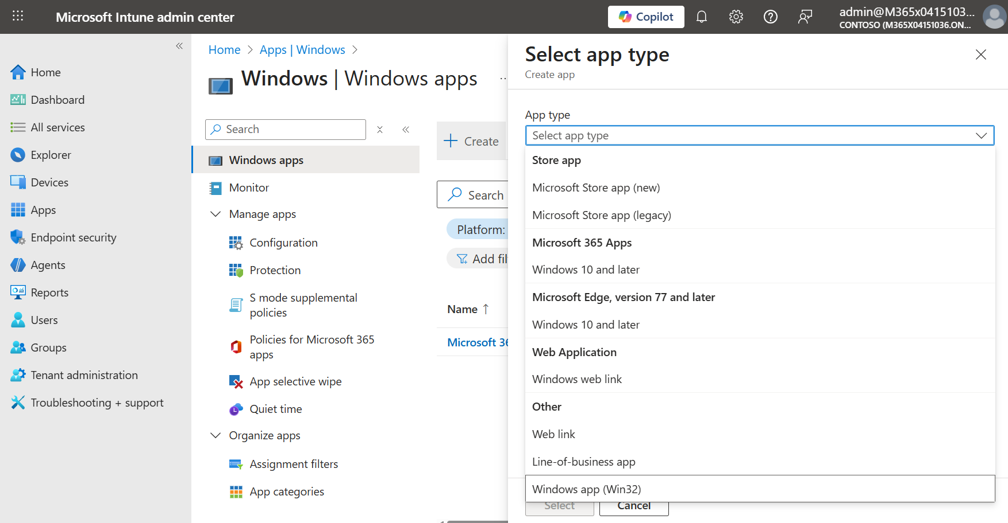

Note:
- Deployment options only install the apps on the device. These options do not pin the apps.
- Companion apps are only available for Windows 11 devices.

Which is the recommended option for deployment?
The recommended option for companion apps' deployment is to install via Microsoft 365 App updates. The installation is automatic, requires no action from the admins, and is less disruptive to users.

Can I deploy in rings via Intune first and later install the apps for the rest?
Yes. First, turn off automatic installation of companion apps as part of the Microsoft 365 Apps update via this setting. Go to Microsoft 365 Apps admin center → Device Configuration → Modern App settings → Un-check Enable automatic installation of Microsoft 365 companion apps. 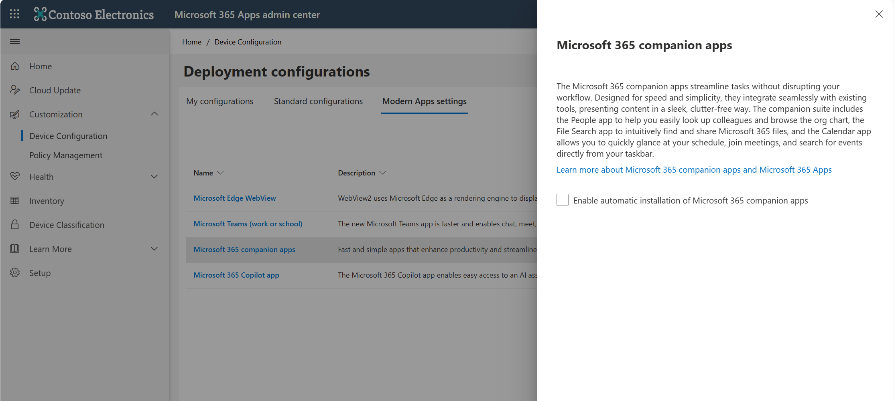Then use Microsoft Intune to deploy in rings. When you are ready to enable it for the rest of the tenant, enable automatic installation for the remaining devices by checking the ‘Enable automatic installation of Microsoft 365 companion apps’ setting. This will install companion apps for the rest of the eligible devices that don’t have companion apps installed.

Where can I find the install, uninstall and the detection scripts needed for Intune distribution of companion apps as Win32 app?
Please find the detailed guide including sample scripts in our deployment guide.

Are companion apps part of Microsoft 365 Apps installation?
When Microsoft 365 Apps are installed for the first time on any device, companion apps are not installed with it. Once the Microsoft 365 Apps are installed, they regularly receive an update depending on the update settings configured. When the Microsoft 365 Apps receive an update, the companion apps are then installed as part of the update.
We are working on having companion apps bundled with first/new installation of Microsoft 365 Apps which means when Microsoft 365 Apps are installed for the first time (aka new installation), it will allow admins to install companion apps too, if needed.

Once the user uninstalls the companion apps from their device, will it automatically re-install due to a subsequent Microsoft 365 Apps update?
Uninstalling any of the companion apps from the device will uninstall all 3 companion apps. Once the companion apps are uninstalled, any subsequent update to Microsoft 365 Apps won’t reinstall the companion apps on the device. The user can download the suite from here Microsoft 365 Companions info page.

Once the user uninstalls the companion apps from their device, will it automatically re-install via Microsoft Intune?
Uninstalling any of the companion apps from the device will uninstall all 3 companion apps. If the companion apps were deployed via Microsoft Intune, reinstall behavior will depend on the configuration during Intune distribution.
In the Assignments step, if the users are assigned as ‘Required’, the apps will be re-installed when the device restarts and syncs with Intune.
If the users are assigned as ‘Available for enrolled devices’, the apps will not be re-installed. In case of this type of assignment, the apps are not installed on the device but made available in the ‘Company Portal’ app. Users can then choose to install the apps from the Company portal.
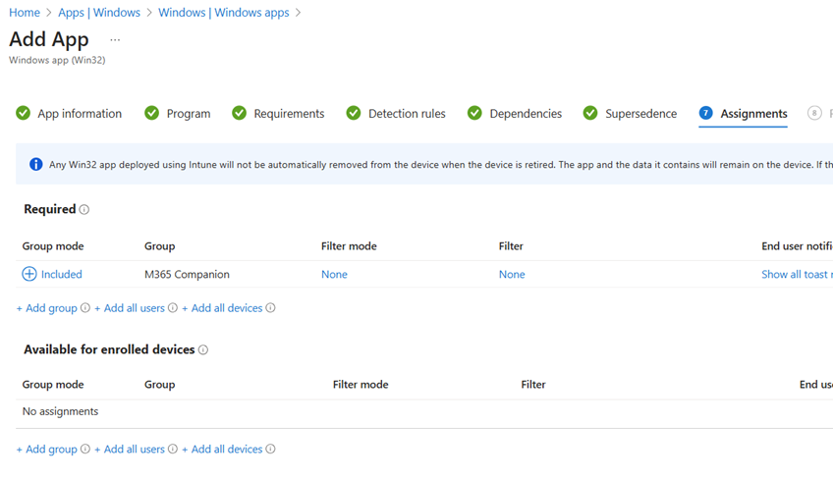

Can I deploy only specific companion apps and not all three?
People, Files, and Calendar are part of the Microsoft 365 companion apps and cannot be installed individually. All 3 apps are installed together. When users uninstall, all 3 apps get uninstalled.

How can admins turn off automatic installation?
Companion apps will be installed to the eligible devices by default when Microsoft 365 Apps update. If you don’t want to install the companion apps, you can simply turn off automatic installation using this setting before the apps are installed.
Go to Microsoft 365 Apps admin center → Device Configuration → Modern App settings → un-check Enable automatic installation of Microsoft 365 companion apps.

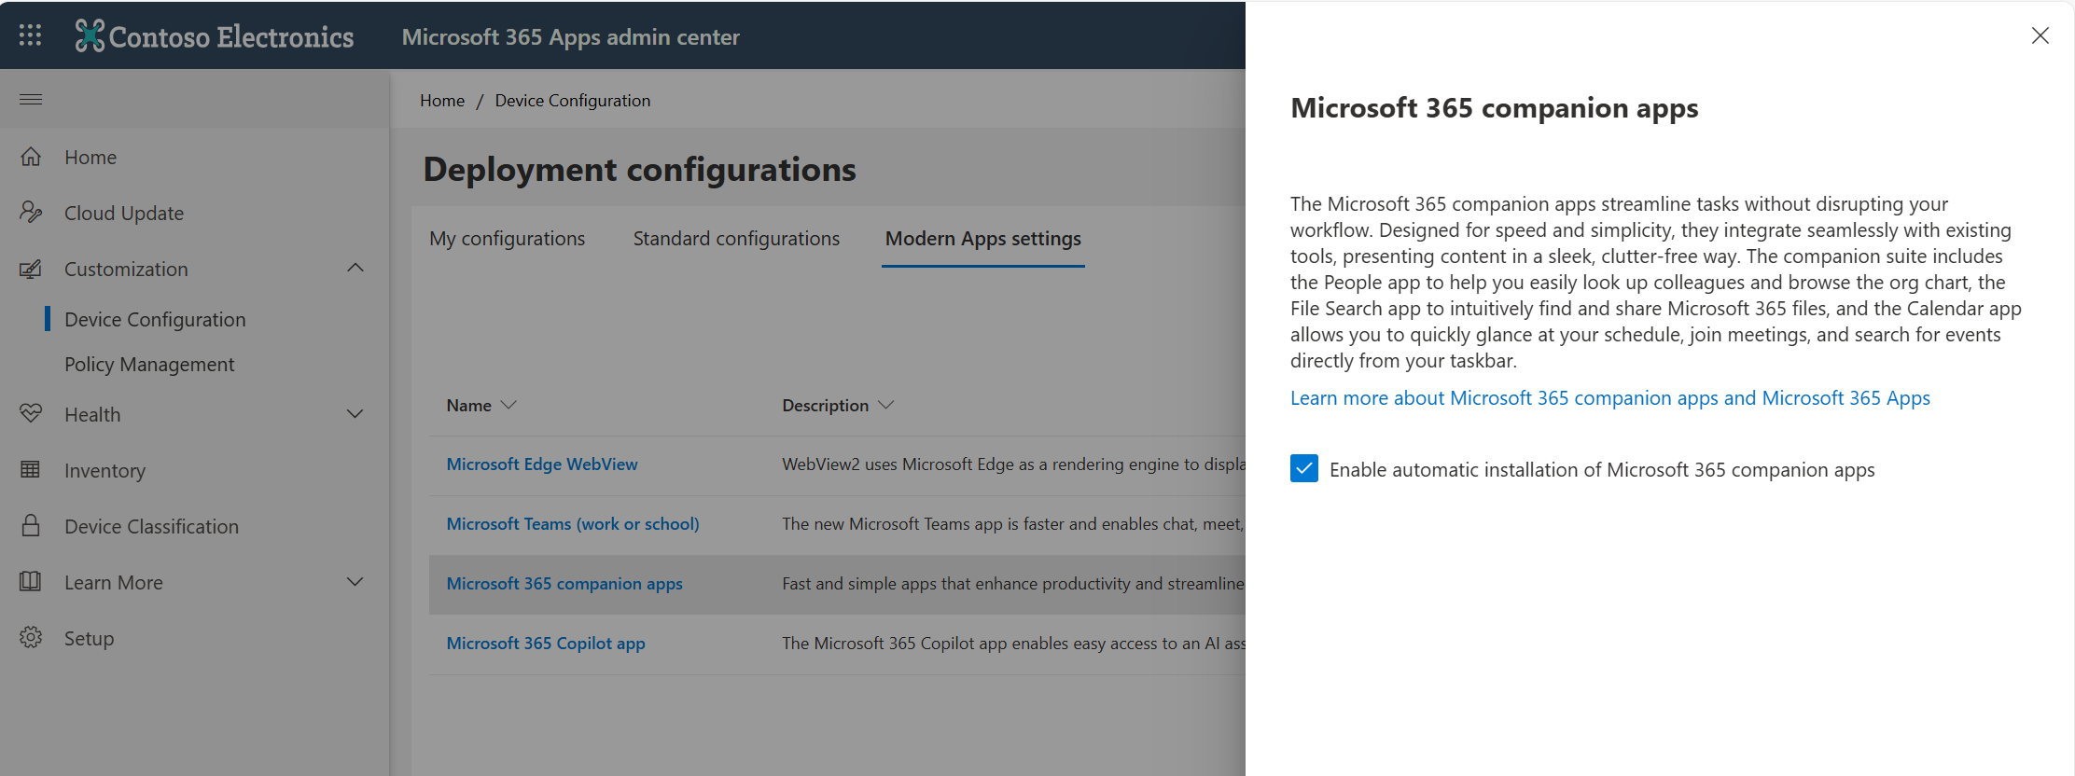

Start-up Behavior

Do the companion apps auto-launch/start-up?
Once installed, the companion apps do not auto launch. They are also not set up as start-up apps on install. When a user opens the app, that specific app is set up as start-up app. Users can disable start-up in app settings or Windows Start-up settings.

In app start up setting:
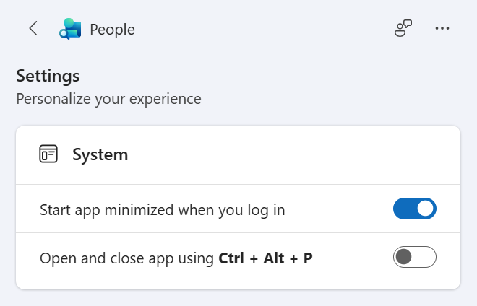

Windows Startup setting:
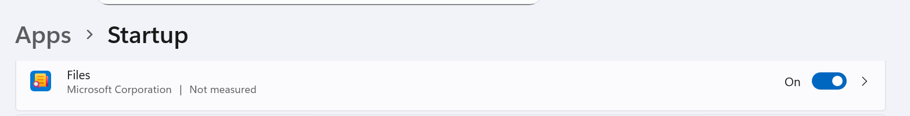

Can admins disable the start-up of the apps?
When a user opens the app, that specific app is set up as start-up app. Users can disable start-up in app settings or Windows Start-up settings. Admins can disable this start-up on opening of the apps by navigating to config.office.com -> Customization -> Policy management -> Create/Update office policies -> Choose Scope -> Search for ‘Companions’ or this setting: ‘Prevent Microsoft 365 companions from starting automatically’ -> Enable the setting per app.

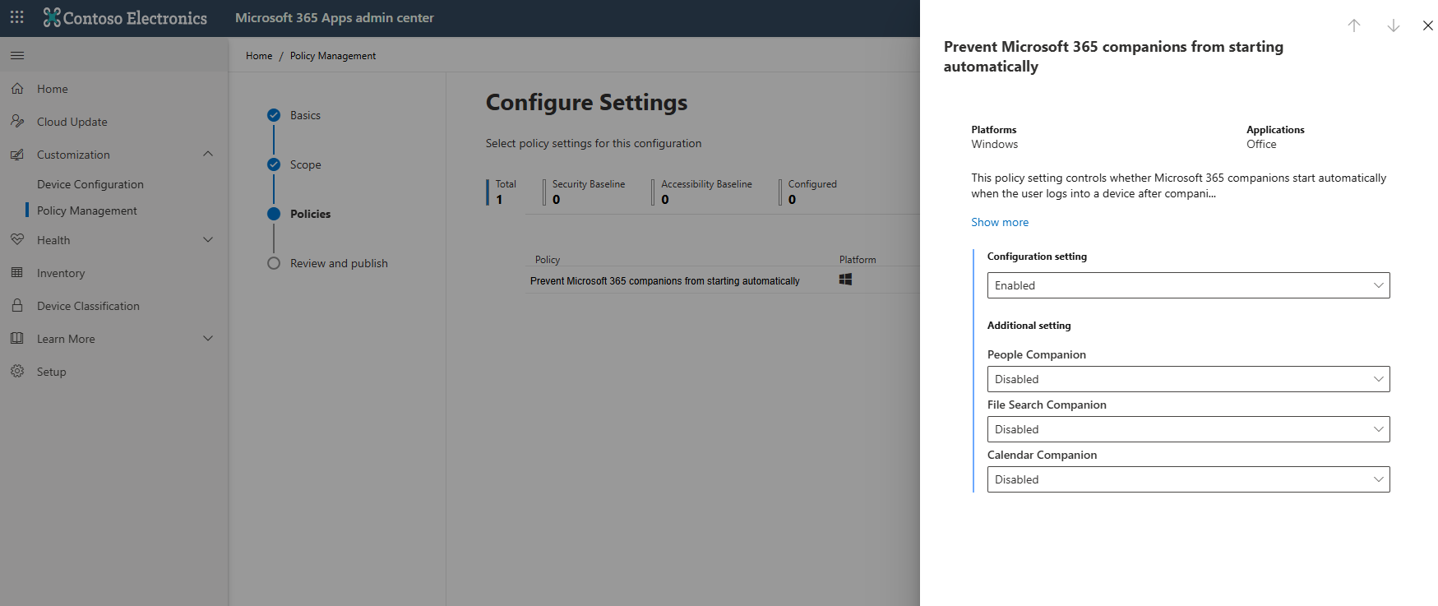

Pinning Behavior

What are the options for pinning Companions to the taskbar?
Admins have the following options for pinning:
- Pin Companions using a quick toggle in Microsoft 365 Admin Center.
- Pin Companions manually using an Intune policy in Intune Admin Center.

Pin Companions using a quick toggle in Microsoft 365 Admin Center.
Use the Pin Microsoft 365 Copilot and its companion apps to the Windows taskbar setting in the Microsoft 365 Admin center for Intune-managed devices.
Pin Microsoft 365 Copilot and its companion apps to the Windows taskbar | Microsoft Learn

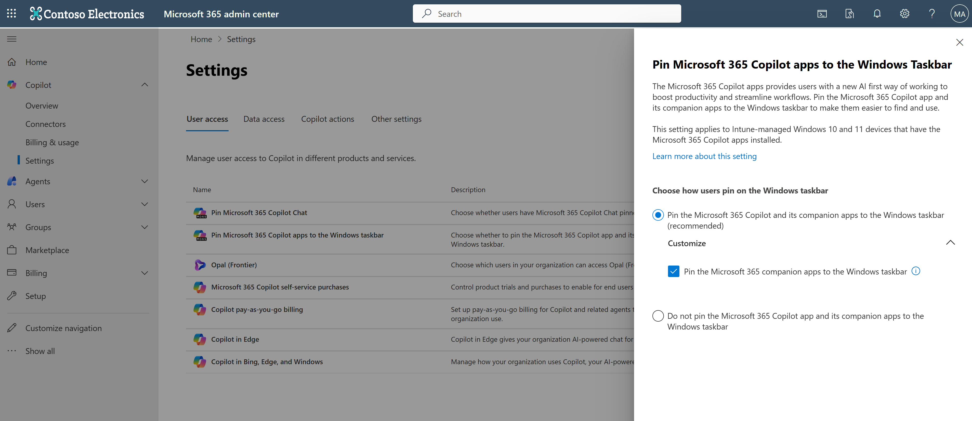

Pin Companions manually using an Intune policy in Intune Admin Center
The Microsoft 365 Admin Center pinning toggle is a simple, tenant‑wide entry point. For selective pinning (only some users/devices), assign an Intune policy or a script to target Azure AD groups. Check out an example of the Intune pinning policy setup in our deployment guide. You can find Microsoft docs on taskbar pinning policy here: Configure the Windows Taskbar Pinned Apps with Policy Settings | Microsoft Learn

What does the Copilot + Companions pinning toggle do?
The Microsoft 365 Admin Center Copilot + Companions pinning toggle deploys via Microsoft Intune a taskbar pinning policy to all devices in the tenant that pins Microsoft Copilot app on all Windows devices and Microsoft 365 companion apps on all Windows 11 devices, if the apps exist on the device.

Can I pin only some apps and not all the 3 apps? Can I pin only for some users and not the entire tenant?
Yes, through Microsoft Intune. The Microsoft 365 Admin Center pinning toggle is a simple, tenant‑wide entry point. For selective pinning (only some users/devices), assign an Intune policy or a script to target Azure AD groups. Any customization beyond the global toggle should be done via Microsoft Intune (and optional scripting) for precise, ring‑based control. Check out an example of the Intune pinning policy setup in this deployment guide. You can find Microsoft docs on taskbar pinning policy here: Configure the Windows Taskbar Pinned Apps with Policy Settings | Microsoft Learn

What if I don’t have the apps installed when the Copilot + Companions pinning policy is turned on?
There will be no effect on the device until the apps are installed. Once installed, if the pinning policy is on, the apps will show pinned to the taskbar.

What happens when a user, who had the apps pinned to the taskbar with Copilot + Companions pinning toggle, unpins the apps from the taskbar?
The Copilot + Companions pinning toggle deploys via Microsoft Intune a taskbar pinning policy to all devices in the tenant that pins Microsoft Copilot app on all Windows devices and Microsoft 365 Companion apps on all Windows 11 devices, if the apps exist on the device.
This taskbar pinning policy has the setting PinGeneration="1" which implies that the apps shouldn’t reappear on the taskbar once unpinned.
This setting is only recognized by devices with Windows 11 [version 24H2 with KB5060829 and 23H2 with KB5060826] and beyond. For users on these devices, if they unpin the apps, the apps won't reappear pinned on the taskbar.
This setting is not recognized by devices with Windows 11 prior to May retail release [Build 26100.4202+], or any devices with Windows 10. For users on these devices, it will allow users to unpin the apps, but the apps will reappear pinned on the taskbar when the device syncs with Intune.

Can I use the Copilot + Companions pinning toggle if I already have a taskbar pinning policy in place?
Yes, you can — but it’s important to know how they behave together.
The Microsoft 365 Admin Center toggle applies tenant‑wide.
Your existing Intune pinning continues to work only for the groups you targeted.
Devices/users not covered by your Intune policy will receive the tenant‑wide toggle pin.
Recommendation:
If you want to keep ring-based or selective pinning, stay with Intune and don’t turn on the toggle.
If you want to expand pinning to everyone else, then you can safely enable the toggle — it won’t break the Intune targeting you already have.

Can users unpin AND not have apps start-up after unpinning because this creates confusion?
Pinning and start-up are separate behaviors managed independently. Unpinning only removes the app icon from the taskbar. If you want to disable start-up for these apps, you can configure an office policy via the Microsoft 365 App Admin center. Check out the start-up behavior section. Users can turn off app start-up using the app settings or Windows start-up settings.

Updates & Versioning

How often do the companion apps update?
The apps update themselves after they have been installed. Updates run automatically in the background without user interaction and are less disruptive to a user’s workflow. Update cadence varies dependent on readiness of new functionality and quality improvements, but since launch has been roughly twice a month.

What is the link between Office versioning and Companions versions numbers?

There is no link between Office versioning and companion app versioning. For companion app versions, the current format 2.2512.12000.0 reflects a major version, YYMM date and a day‑specific build number, which can give some indication of the age of a build.

Monitoring & Reporting

Where can I see deployment and adoption dashboards?
- M365 Admin Center: No dedicated dashboards yet.
- Intune: Use app deployment and adoption reports for installation status and usage. Admins will need to manually generate the reports.
Intune deployment reports: https://learn.microsoft.com/en-us/intune/intune-service/apps/app-management
Intune adoption reports: https://learn.microsoft.com/en-us/intune/analytics/app-reliability

If deployed via Microsoft 365 Apps update, how do I track adoption?
Use Intune reporting (if devices are managed) or SCCM/third-party inventory tools.

Best practices for successful deployment and adoption
Based on early customer feedback and deployment learnings, the following best practices are recommended:
- Announce the apps to end users
It’s recommended to send an internal announcement before or at the time of deployment to help users understand what the companion apps are and how they can be used. Below is an example of a ready-to-use announcement template for organizations that have deployed and pinned the companion apps to the taskbar:
Subject: New magic on your taskbar: Microsoft 365 companion apps

Hi {{organization}},

Starting soon, you’ll notice something new on your Windows 11 taskbar — Microsoft 365 companion apps: the fastest way to find People, Files, and Calendar.

Because they live on the taskbar, companion apps are always just one click away, making it easy to stay focused, find what you need fast, and take action.
Here’s what you’ll get:

- People: look up colleagues by name, location, role, skills and more, view profiles and org charts
- Files: fastest way to find files across Microsoft 365; search by file name, keyword, person, or file type
- Calendar: glance at your day, join meetings or RSVP instantly

With Copilot integration, you can go from finding to doing, from summarizing a document to catching up on a missed meeting and getting quick context about a teammate before a meeting.

When it's happening:
These apps will automatically appear on your Windows 11 taskbar starting {{date}}. No action is needed from you.

Why it matters:
Microsoft 365 companion apps help reduce context-switching and save time every day, keeping you in flow while you work. We recommend pinning the apps to keep them in the same spot every time you sign in and for an easy flow with Copilot on the taskbar.

Privacy note: The apps only show information you already have permission to access in Microsoft 365.
Learn more:
Get started with Microsoft 365 companion apps - Microsoft Support

Questions? Contact {{helpdesk email}}.

Thank you,
{{Admin / IT Department Name}}

- Keep the companion apps easily accessible
Microsoft 365 companion apps are designed to live on the Windows 11 taskbar, where their core value comes from being instantly accessible. When pinned, companions appear together with Copilot, creating a consistent and highly visible entry point for people, files, calendar, and Copilot-powered actions. For a better experience, it’s recommended to pin the apps by default or encourage users to pin them themselves.

Quick Links
Microsoft 365 Companion Apps Info Page: Contains companion apps overview, key features and screenshots. | Microsoft 365 companion apps info page.  .
Microsoft 365 Companion Apps Learn Page: Contains deployment details, license eligibility etc. | Microsoft 365 companions apps overview - Microsoft 365 Apps | Microsoft Learn
Microsoft 365 Companion Apps Pinning: Contains Copilot + companion apps pinning details | Pin Microsoft 365 Copilot and its companion apps to the Windows taskbar | Microsoft Learn
Microsoft 365 Companion Apps Adoption Resources | Microsoft 365 – Microsoft Adoption

