Deploying M365 Companion apps Using Microsoft Intune (Including Taskbar Pinning via Configuration Policy)
This guide outlines the full process for deploying the application through Intune. The application package includes:
- An installation script
- An uninstall script
- A detection script
- A setup.exe file

Section 1: Deploy the Win32 App via Intune (Prepare a Win32 app to be uploaded to Microsoft Intune | Microsoft Learn)
Step 1: Prepare the App Package
- Create the install.ps1, uninstall.ps1 and detection.ps1 files as suggested. Test the scripts locally to ensure they work and adjust for user/system context.
Install.ps1 (-FilePath argument have the exe path)
Start-Process -FilePath "m365companionsetup.exe" -ArgumentList "/install /quiet /norestart" -Wait

uninstall.ps1
# Remove for all users
Get-AppxPackage -AllUsers -Name "Microsoft.M365Companions*" | Remove-AppxPackage -AllUsers

detection.ps1
$App = Get-AppxPackage -AllUsers | Where-Object {
$_.PackageFamilyName -eq "Microsoft.M365Companions_8wekyb3d8bbwe"
}

if ($App) {
Write-Output "Installed"
exit 0
}
else {
exit 1
}
For setup.exe, download from the M365 Companions page.
- Place the following files into a single folder:
  - install.ps1
  - uninstall.ps1
  - detection.ps1
  - setup.exe file
- Use the IntuneWinAppUtil.exe to package the folder:
  - Command format:
  - This generates a .intunewin file.

Step 2: Upload and Configure the App in Intune
- Go to Microsoft Endpoint Manager Admin Center.
- Navigate to Apps > Windows > Add.
- Select App type: Windows app (Win32).
- In the App information tab:
  - Upload the .intunewin package.
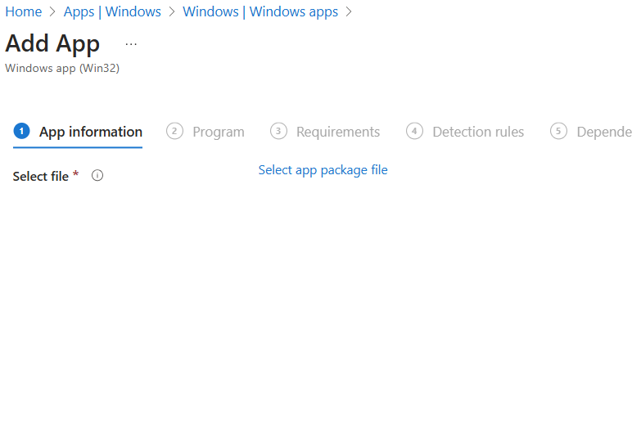
  - Fill in name, description, publisher, etc.
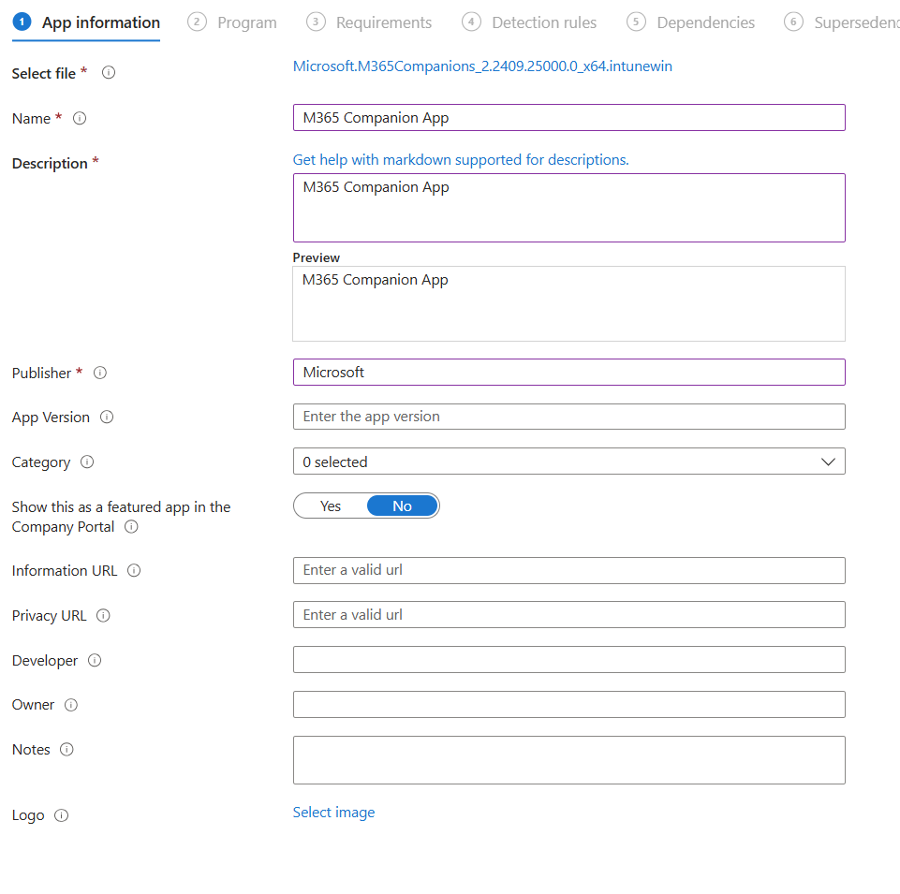

Step 3: Configure Program Install/Uninstall Commands
- Using the install and uninstall scripts as reference, enter the install and uninstall commands.
- For “Install command”, simply adding this command should work:
  - m365companionsetup.exe -q -p OR
  - m365companionsetup.exe /install /quiet /norestart
- For “Uninstall command”, simply adding this command should work:
  - powershell.exe -ExecutionPolicy Bypass -Command "Get-AppxPackage -AllUsers -Name 'Microsoft.M365Companions' | Remove-AppxPackage -AllUsers"
- Choose “System” for “Install Behavior”.
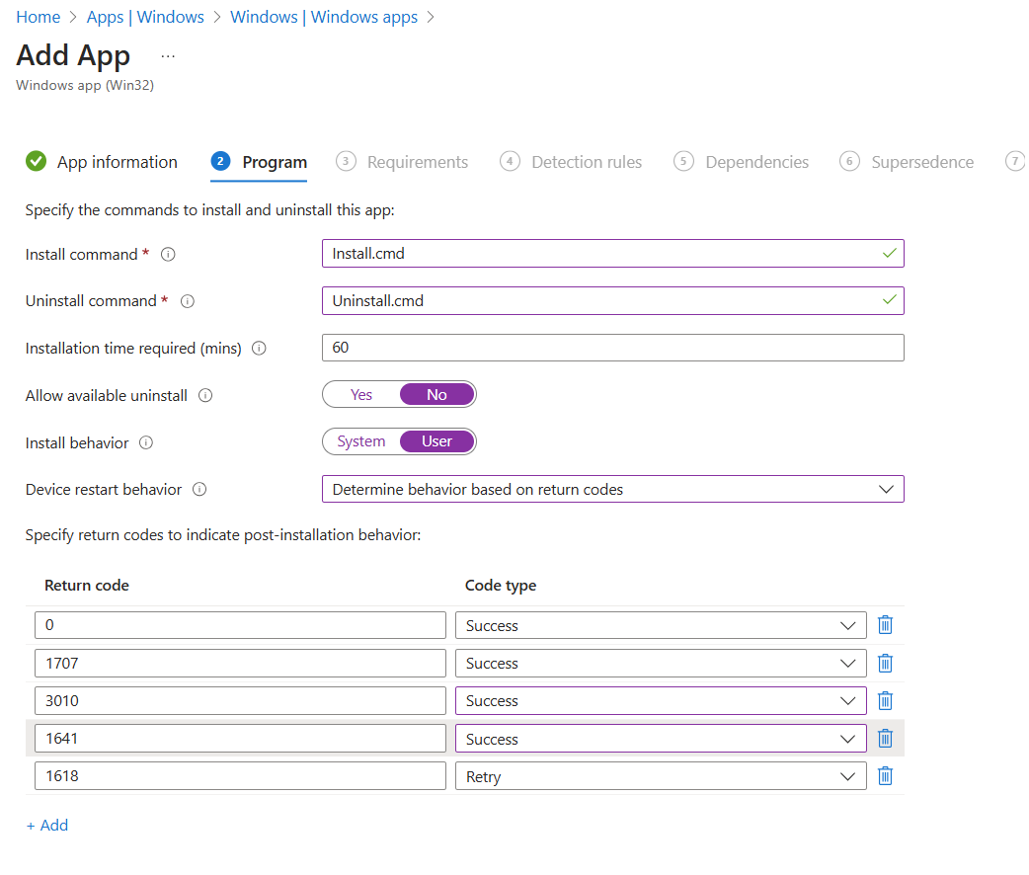

Step 4: Set Requirements (Optional)
- Set OS version or other requirements if needed.

Step 5: Add Detection Rule
- Choose Custom script as detection type.
- Upload the detection.ps1 script or use this:
$App = Get-AppxPackage -AllUsers | Where-Object {
$_.PackageFamilyName -eq "Microsoft.M365Companions_8wekyb3d8bbwe"
}

if ($App) {
Write-Output "Installed"
exit 0
}
else {
exit 1
}

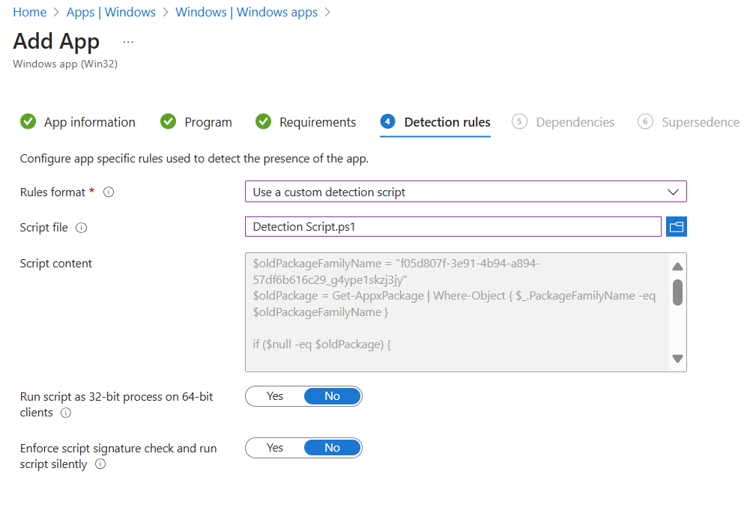

Step 6: Configure Dependencies & Supersedence (Optional)

Step 7: Assign the App
- Assign the app (as Required) to groups under Assignments.
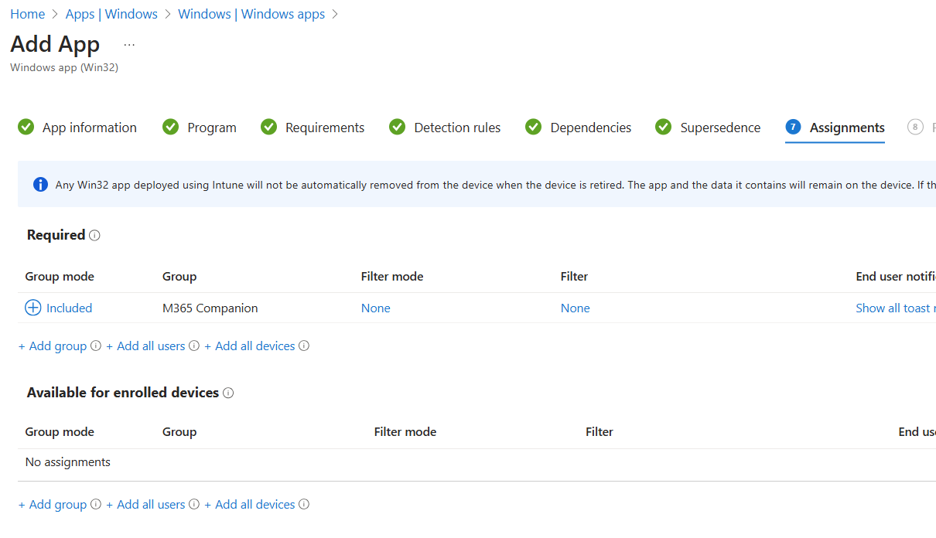
Step 8: Monitor Deployment.
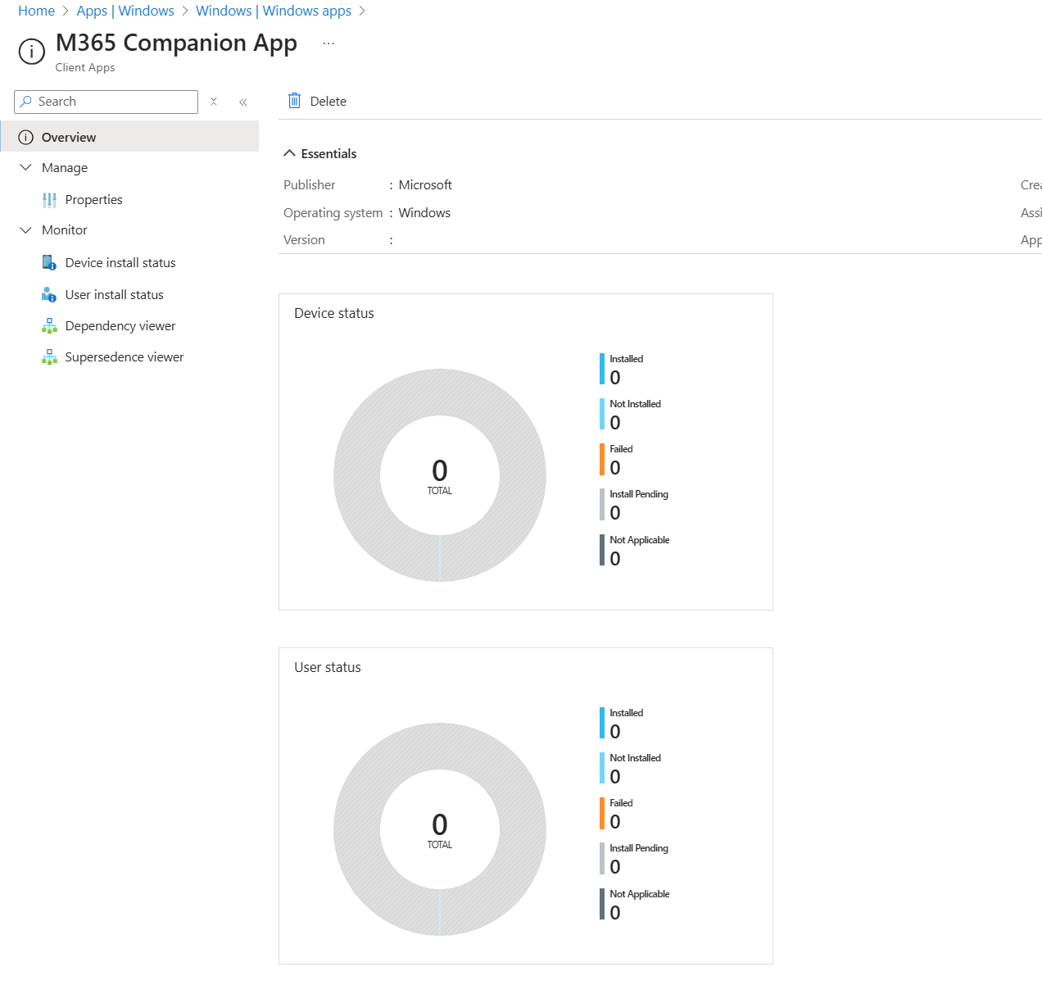
Section 2: Pin the App to Taskbar Using Configuration Profile
Learn Page Pin Apps to Taskbar
Step 1: Create the Taskbar XML File
Sample layout.xml that pins Microsoft 365 Copilot and Microsoft 365 Companion apps:
<?xml version="1.0" encoding="utf-8"?>
<LayoutModificationTemplate xmlns="http://schemas.microsoft.com/Start/2014/LayoutModification"
xmlns:defaultlayout="http://schemas.microsoft.com/Start/2014/FullDefaultLayout"
xmlns:start="http://schemas.microsoft.com/Start/2014/StartLayout"
xmlns:taskbar="http://schemas.microsoft.com/Start/2014/TaskbarLayout" Version="1">
<CustomTaskbarLayoutCollection>
<defaultlayout:TaskbarLayout>
<taskbar:TaskbarPinList>
<taskbar:DesktopApp DesktopApplicationID="Microsoft.MicrosoftOfficeHub_8wekyb3d8bbwe!Microsoft.MicrosoftOfficeHub" PinGeneration="1"/>
<taskbar:DesktopApp DesktopApplicationID="Microsoft.M365Companions_8wekyb3d8bbwe!People" PinGeneration="1"/>
<taskbar:DesktopApp DesktopApplicationID="Microsoft.M365Companions_8wekyb3d8bbwe!Files" PinGeneration="1"/>
<taskbar:DesktopApp DesktopApplicationID="Microsoft.M365Companions_8wekyb3d8bbwe!Calendar" PinGeneration="1"/>
</taskbar:TaskbarPinList>
</defaultlayout:TaskbarLayout>
</CustomTaskbarLayoutCollection>
</LayoutModificationTemplate>
Step 2: Upload XML and Create Configuration Profile
- Go to Devices > Configuration profiles > Create profile.
- Platform: Windows 10 and later
- Profile type: Templates > Device Restrictions
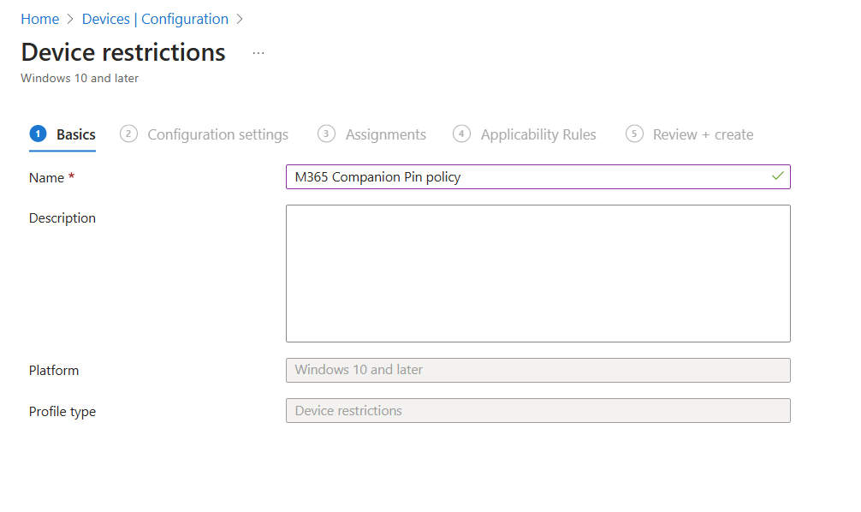
- Configuration settings > Start > Upload the xml file
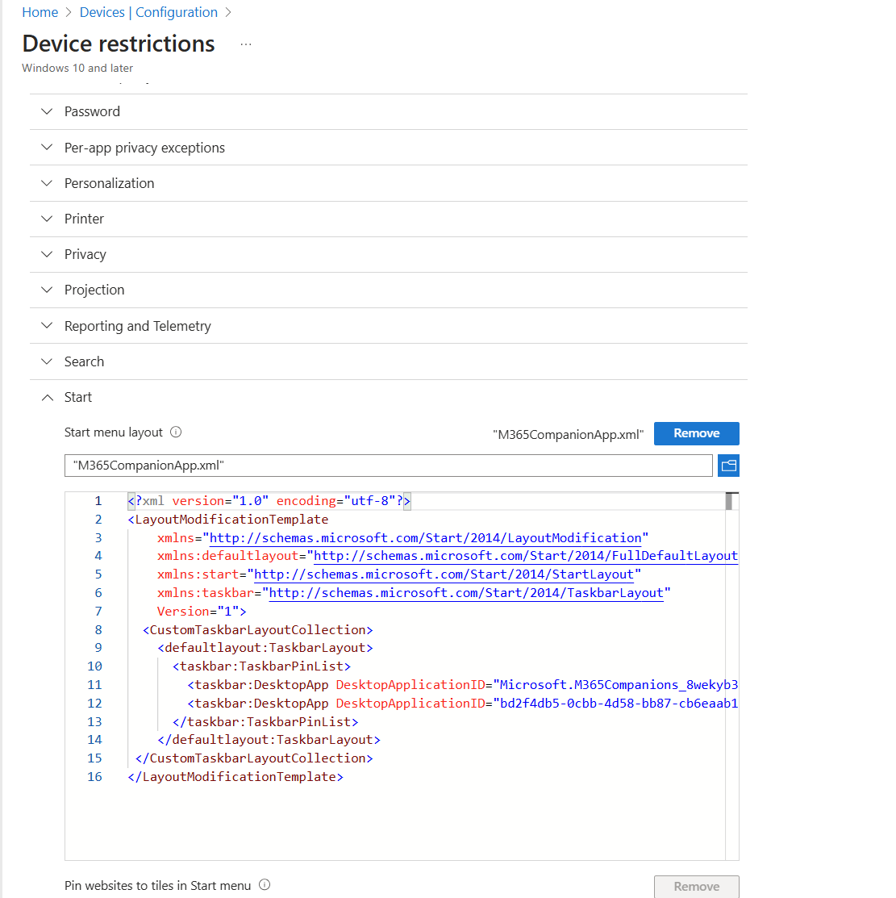
Step 3: Assign the Policy
- Assign the configuration profile to your target user group.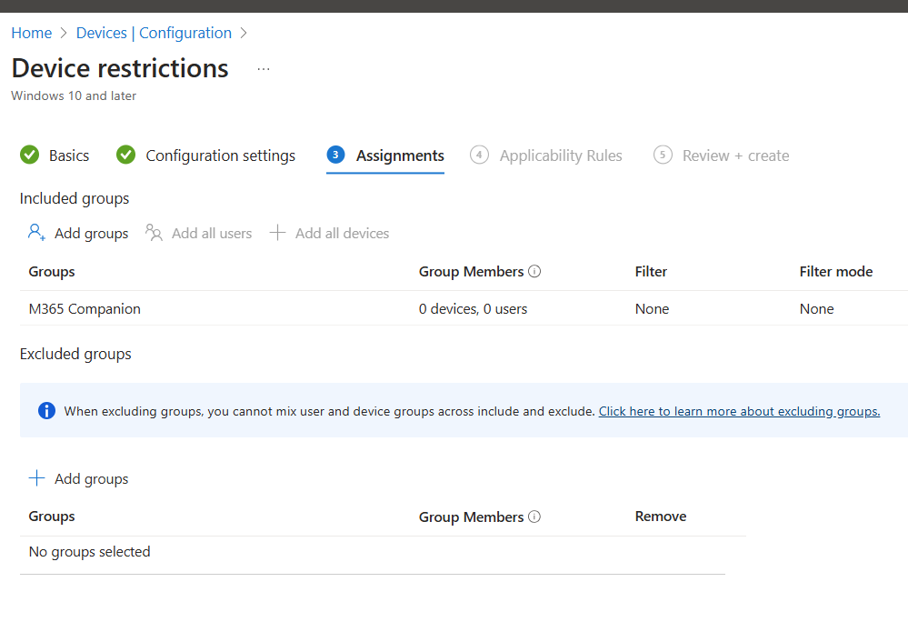
Step 4: Validate Taskbar Pinning
- Once the policy is applied, log into a user session and verify that the app appears on the taskbar.
- This may require a sign-out or device restart.
