Explore new skills

Find the right content and discover relevant skills with personalized suggestions based on your own interests.

Learn in the flow of work

Regular learning and growth is easier than ever with the new Viva Learning app in Microsoft Teams. Browse learning courses and libraries, access your training assignments, and integrate learning into social features like Teams chat and tabs.

Reach your learning goals

Block focused time for learning by adding learning content to your Outlook calendar. Find learning paths and create learning collections for your personal learning goals or to share with colleagues.

# Introducing Microsoft Viva Learning

## Go to [**aka.ms/VivaLearningDemo**](https://aka.ms/vivalearningdemo) for a guided walkthrough of how to discover, share, and track learning in Viva Learning.

**Learn more about Viva Learning at** [**aka.ms/VivaLearning**](https://aka.ms/vivalearning)

## Start using Viva Learning today!

Make learning a natural part of the day by bringing learning into Microsoft Teams and Microsoft 365.

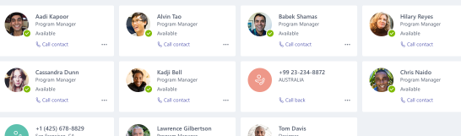

<Add your message here.> Lorem ipsum dolor sit amet, consectetur adipiscing elit. Donec mattis enim eu lorem malesuada hendrerit. Suspendisse eget quam et ipsum pretium ultrices. (200 character max)>

<Your Agency’s Logo Here>

connect with stakeholders across departments in a shared workspace to centralize communication and coordination, connect with people and information from the office or in the field, and securely share and protect sensitive information